






Operate an automated information system
D2.TTA.CL2.14
D2.TGA.CL6.06
Trainee Manual

Operate an automated information system
D2.TTA.CL2.14
D2.TGA.CL6.06
Trainee Manual





Project Base
William Angliss Institute of TAFE
555 La Trobe Street
Melbourne 3000 Victoria
Telephone: | (03) 9606 2111
Facsimile: | (03) 9670 1330
Acknowledgements
Project Director: | Wayne Crosbie
Project Manager | Jim Irwin
Chief Writer: | Alan Hickman
Subject Writer: | Dianne Whelan
Editor: | Jim Irwin
DTP/Production: | Daniel Chee, Mai Vu, Cindy Curran

The Association of Southeast Asian Nations (ASEAN) was established on 8 August 1967. The Member States of the Association are Brunei Darussalam, Cambodia, Indonesia, Lao PDR, Malaysia, Myanmar, Philippines, Singapore, Thailand and Viet Nam.
The ASEAN Secretariat is based in Jakarta, Indonesia.
General Information on ASEAN appears online at the ASEAN Website: www.asean.org.
All text is produced by William Angliss Institute of TAFE for the ASEAN Project on “Toolbox Development for Tourism Labour Divisions for Travel Agencies and Tour Operations”.
This publication is supported by the Australian Government’s aid program through the ASEAN-Australia Development Cooperation Program Phase II (AADCP II).
Copyright: Association of Southeast Asian Nations (ASEAN) 2015.
All rights reserved.
Disclaimer
Every effort has been made to ensure that this publication is free from errors or omissions. However, you should conduct your own enquiries and seek professional advice before relying on any fact, statement or matter contained in this book. The ASEAN Secretariat and William Angliss Institute of TAFE are not responsible for any injury, loss or damage as a result of material included or omitted from this course. Information in this module is current at the time of publication. Time of publication is indicated in the date stamp at the bottom of each page.
Some images appearing in this resource have been purchased from stock photography suppliers Shutterstock and iStockphoto and other third party copyright owners and as such are non-transferable and non-exclusive. Clip arts, font images and illustrations used are from the Microsoft Office Clip Art and Media Library. Some images have been provided by and are the property of William Angliss Institute.
Additional images have been sourced from Flickr and SXC and are used under Creative Commons licence: http://creativecommons.org/licenses/by/2.0/deed.en

File name: TM_Operate_an_automated_information_system_230715





Table of contents
Introduction to trainee manual 1
Unit descriptor 3
Assessment matrix 5
Glossary 7
Element 1: Identify the context for use of an automated information system 9
Element 2: Access information using an automated information system 59
Element 3: Obtain information using an automated information system 91
Element 4: Use information from an automated information system 107
Element 5: Up-date and maintain information on an automated information system 131
Presentation of written work 139
Recommended reading 141
Trainee evaluation sheet 143
Trainee self-assessment checklist 145

Introduction to trainee manual

To the Trainee
Congratulations on joining this course. This Trainee Manual is one part of a ‘toolbox’ which is a resource provided to trainees, trainers and assessors to help you become competent in various areas of your work.
The ‘toolbox’ consists of three elements:
- A Trainee Manual for you to read and study at home or in class
- A Trainer Guide with Power Point slides to help your Trainer explain the content of the training material and provide class activities to help with practice
- An Assessment Manual which provides your Assessor with oral and written questions and other assessment tasks to establish whether or not you have achieved competency.
The first thing you may notice is that this training program and the information you find in the Trainee Manual seems different to the textbooks you have used previously. This is because the method of instruction and examination is different. The method used is called Competency based training (CBT) and Competency based assessment (CBA). CBT and CBA is the training and assessment system chosen by ASEAN (Association of South-East Asian Nations) to train people to work in the tourism and hospitality industry throughout all the ASEAN member states.
What is the CBT and CBA system and why has it been adopted by ASEAN?
CBT is a way of training that concentrates on what a worker can do or is required to do at work. The aim is of the training is to enable trainees to perform tasks and duties at a standard expected by employers. CBT seeks to develop the skills, knowledge and attitudes (or recognise the ones the trainee already possesses) to achieve the required competency standard. ASEAN has adopted the CBT/CBA training system as it is able to produce the type of worker that industry is looking for and this therefore increases trainees chances of obtaining employment.
CBA involves collecting evidence and making a judgement of the extent to which a worker can perform his/her duties at the required competency standard. Where a trainee can already demonstrate a degree of competency, either due to prior training or work experience, a process of ‘Recognition of Prior Learning’ (RPL) is available to trainees to recognise this. Please speak to your trainer about RPL if you think this applies to you.
What is a competency standard?
Competency standards are descriptions of the skills and knowledge required to perform a task or activity at the level of a required standard.
242 competency standards for the tourism and hospitality industries throughout the ASEAN region have been developed to cover all the knowledge, skills and attitudes required to work in the following occupational areas:
- Housekeeping
- Food Production
- Food and Beverage Service
- Front Office
- Travel Agencies
- Tour Operations.
All of these competency standards are available for you to look at. In fact you will find a summary of each one at the beginning of each Trainee Manual under the heading ‘Unit Descriptor’. The unit descriptor describes the content of the unit you will be studying in the Trainee Manual and provides a table of contents which are divided up into ‘Elements’ and ‘Performance Criteria”. An element is a description of one aspect of what has to be achieved in the workplace. The ‘Performance Criteria’ below each element details the level of performance that needs to be demonstrated to be declared competent.
There are other components of the competency standard:
- Unit Title: statement about what is to be done in the workplace
- Unit Number: unique number identifying the particular competency
- Nominal hours: number of classroom or practical hours usually needed to complete the competency. We call them ‘nominal’ hours because they can vary e.g. sometimes it will take an individual less time to complete a unit of competency because he/she has prior knowledge or work experience in that area.
The final heading you will see before you start reading the Trainee Manual is the ‘Assessment Matrix’. Competency based assessment requires trainees to be assessed in at least 2 – 3 different ways, one of which must be practical. This section outlines three ways assessment can be carried out and includes work projects, written questions and oral questions. The matrix is designed to show you which performance criteria will be assessed and how they will be assessed. Your trainer and/or assessor may also use other assessment methods including ‘Observation Checklist’ and ‘Third Party Statement’. An observation checklist is a way of recording how you perform at work and a third party statement is a statement by a supervisor or employer about the degree of competence they believe you have achieved. This can be based on observing your workplace performance, inspecting your work or gaining feedback from fellow workers.
Your trainer and/or assessor may use other methods to assess you such as:
- Journals
- Oral presentations
- Role plays
- Log books
- Group projects
- Practical demonstrations.
Remember your trainer is there to help you succeed and become competent. Please feel free to ask him or her for more explanation of what you have just read and of what is expected from you and best wishes for your future studies and future career in tourism and hospitality.

Unit descriptor
Operate an automated information system
This unit deals with the skills and knowledge required to Operate an automated information system in a range of settings within the travel industries workplace context.
Unit Code:
D2.TTA.CL2.14
D2.TGA.CL6.06
Nominal Hours:
50

Element 1: Identify the context for use of an automated information system
Performance Criteria
1.1 Identify a range of information systems and sources in use within the industry
1.2 Describe policies and procedures for operating an automated information system
1.3 List information that may be available through an automated information system
1.4 Identify the functions of an automated information system

Element 2: Access information using an automated information system
Performance Criteria
2.1 Identify information requirements
2.2 Identify and select appropriate sources of information
2.3 Apply search techniques to locate identified information
2.4 Interrogate the system to secure full range of information available on the system
2.5 Verify captured information meets identified need

Element 3: Obtain information using an automated information system
Performance Criteria
3.1 Enable access to required system and/or information
3.2 Select required information
3.3 Download information
3.4 Print information

Element 4: Use information from information an automated information system
Performance Criteria
4.1 Forward information as required
4.2 Save identified information
4.3 Manipulate accessed information
4.4 Report on findings

Element 5: Up-date and maintain information on an automated information system
Performance Criteria
5.1 Enter data onto automated information system
5.2 Save and back-up data

Assessment matrix
Showing mapping of Performance Criteria against Work Projects, Written Questions and Oral Questions
The Assessment Matrix indicates three of the most common assessment activities your Assessor may use to assess your understanding of the content of this manual and your performance - Work Projects, Written Questions and Oral Questions. It also indicates where you can find the subject content related to these assessment activities in the Trainee Manual (i.e. under which element or performance criteria). As explained in the Introduction, however, the assessors are free to choose which assessment activities are most suitable to best capture evidence of competency as they deem appropriate for individual students.
 |  |  | Work Projects | Written Questions | Oral Questions
Element 1: Identify the context for use of an automated information system
1.1 | Identify a range of information systems and sources in use within the industry |  | 1 | 1, 2 | 1
1.2 | Describe policies and procedures for operating an automated information system |  | 2 | 3, 4 | 2
1.3 | List information that may be available through an automated information system |  | 3, 4 | 5 | 3
1.4 | Identify the functions of an automated information system |  | 5 | 6, 7 | 4
Element 2: Access information using an automated information system
2.1 |  | Identify information requirements | 6 | 8 | 5
2.2 |  | Identify and select appropriate sources of information | 3, 4 | 9, 10 | 6
2.3 |  | Apply search techniques to locate identified information | 7, 8, 9, 10 | 11, 12 | 7
2.4 |  | Interrogate the system to secure full range of information available on the system | 11, 12, 13 | 13, 14, 15 | 8
2.5 |  | Verify captured information meets identified need | 14 | 16 | 9
Element 3: Obtain information using an automated information system
3.1 | Enable access to required system and/or information |  | 15 | 17, 18 | 10
3.2 | Select required information |  | 16 | 19, 20 | 11
3.3 | Download information |  | 17 | 21 | 12
3.4 | Print information |  | 17 | 22 | 13
Element 4: Use information from information an automated information system
4.1 |  | Forward information as required | 18 | 23 | 14
4.2 |  | Save identified information | 19 | 24 | 15
4.3 |  | Manipulate accessed information | 20 | 25 | 16
4.4 |  | Report on findings | 21 | 26, 27 | 17
Element 5: Up-date and maintain information on an automated information system
5.1 | Enter data onto automated information system |  | 22 | 28, 29 | 18
5.2 | Save and back-up data |  | 23 | 30, 31 | 19

Glossary
Term | Explanation
Amadeus | Amadeus is a computer reservations system (or global distribution system, since it sells tickets for multiple airlines) owned by the Amadeus IT Group with headquarters in Madrid, Spain
Automated pricing | When an airfare will price from a booking automatically
Blog comments | Comments usually centered around the specific subject of the attached blog
Bookmarking | Saving and organising links to any number of online resources and websites
Commission | The money earned for the sale of products on behalf of a principal (e.g.: airline)
CRS | Central Reservation System
Galileo | Galileo is a computer reservations system (CRS) owned by Travelport
GDS | Global Distribution System – computerised reservation network used as a single point of access for travel agents to make airline, hotel and tour reservations
IATA | International Air Transport Association
Microblogging | Short written comments posted on a platform
Platform | Web based technology that enables the development, deployment and management of social media services and solutions.
Quotation | List of components and applicable costs for a proposed holiday
Refund | Reimbursements for services unused
Sabre | The first passenger reservations system offered by Sabre, installed in 1960
Schedule | Planned list of departures and arrivals of an airline between cities
Search engine | A general class of programs, however, the term is often used to specifically describe systems like Google, Bing and Yahoo! Search that enable users to search for documents on the World Wide Web
Social media | Social media is the social interaction among people in which they create, share or exchange information, ideas, and pictures/videos in virtual communities and networks
Social networks | Social media sites that allows users to connect and share with other people who have similar interests and backgrounds
Tag | Keywords attached to a blog post, bookmark, photo or other item of content so you and others can find them easily through searches and aggregation. Tags can usually be freely chosen
Threads | Strands of conversation. On an email list or web forum they will be defined by messages that use the use the same subject.  On blogs they are less clearly defined, but emerge through comments and trackbacks
Wiki | A wiki is a website that allows the easy creation and editing of any number of interlinked web pages via a web browser, allowing for collaboration between users

Element 1:
Identify the context for use of an automated information system

1.1 Identify a range of information systems and sources in use within the industry

Introduction
It is never too early to begin a collection or library of information
There is an abundance of information but you have to be proactive in obtaining it – it won’t simply come to you.
For the tourism industry, the internet has enabled employees to become very knowledgeable, as so much information is available. And if you don’t already have information, you can find it very quickly.
As the internet is available to everyone, customers will often arrive having already completed quite a bit of their own research. It is important you are familiar with the information systems available to you to demonstrate professionalism and currency in your field.
This section will identify several of the excellent reference and information sources which may be of use to you and those who rely on you for assistance.

Automated information systems
Automated information systems are used by many different organisations within the tourism and other industries, and more recently by clients or potential clients via the Internet. Each type of user requires the information for different reasons. The different types of users of automated information systems can include suppliers of tourism services, industry organisations such as retail travel agents and tour wholesalers, tour operators, the media, consumers, the government, and any educational or training organisation.

Central reservation system

The Central Reservation System (CRS) also known as a Global Distribution System (GDS) is a key source of current information in the Tourism industry. The most commonly used are Sabre, Amadeus and Galileo.
The training provided in the use of these various systems (Sabre, Amadeus and Galileo) will equip you to source airfares and their rules. In addition, you will acquire an understanding of the terminology used in the travel industry and the ability to interpret industry jargon and decode data.

Sabre
http://www.sabre.com/index.php/about/our-history
The First passenger reservation system
The first passenger reservations system offered by Sabre, installed in 1960, marked a dramatic leap forward for the airline industry, automating one of its key business areas. In the following years, Sabre Airline Solutions® pioneered technological advances in areas such as revenue management, pricing, flight scheduling, cargo, flight operations and crew scheduling. And not only did we help invent electronic commerce for the travel industry, we hold claim to progressive solutions that defined — and continue to modernise — the travel and transportation marketplace.

Amadeus
From Wikipedia, the free encyclopaedia
Amadeus is a computer reservations system (or global distribution system, since it sells tickets for multiple airlines) owned by the Amadeus IT Group with headquarters in Madrid, Spain. The central database is located at Erding, Germany. The major development centres are located in Bangalore (India), Sophia Antipolis (France) and Boston (United States). In addition to airlines, the CRS is also used to book train travel, cruises, car rental, ferry reservations, and hotel rooms. Amadeus also provides New Generation departure control systems to airlines.[1] Amadeus IT Group is a transaction processor for the global travel and tourism industry. The company is structured around two key related areas - its global distribution system and its IT Solutions business area.
Amadeus is a member of IATA, OTA and SITA. Its IATA airline designator code is 1A
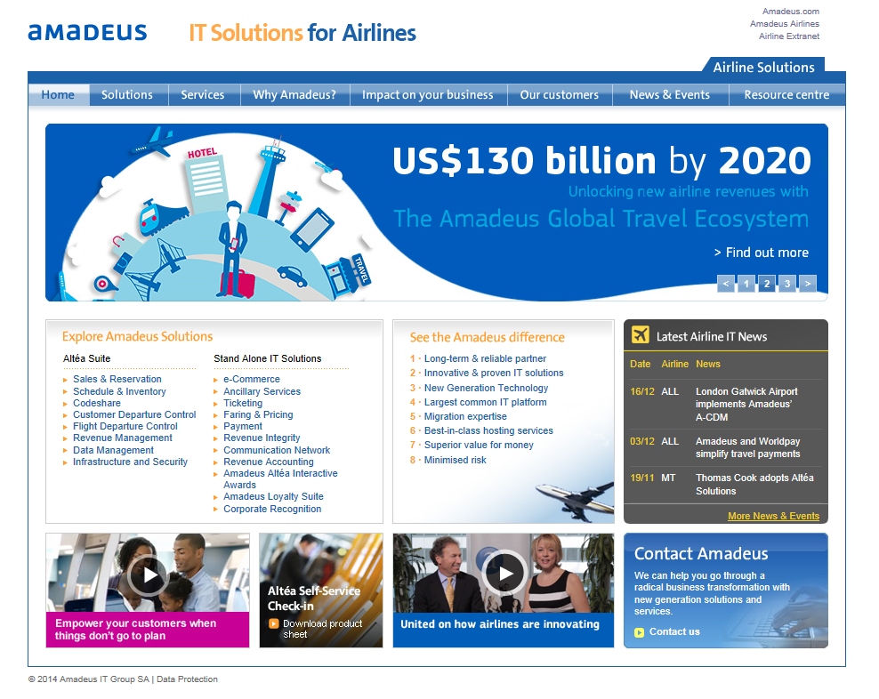

Galileo
From Wikipedia, the free encyclopaedia
Galileo is a computer reservations system (CRS) owned by Travelport. As of 2002, it had a 26.4% share of worldwide CRS airline bookings.[1]
In addition to airline reservations, the Galileo CRS is also used to book train travel, cruises, car rental, and hotel rooms.
The Galileo system was moved from Denver, Colorado, to the Worldspan datacentre in Atlanta, Georgia, on September 28, 2008, following the 2007 merger of Travelport and Worldspan (although they now share the same datacentre, they continue to be run as separate systems).
Galileo is subject to the Capps II and its successor Secure Flight program for the selection of passengers with a risk profile.
Galileo is a member of the International Air Transport Association (IATA), Open Travel Alliance and of SITA.
Example of how the system works
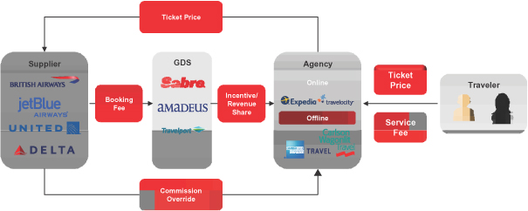

Product database and suppliers
Product databases and suppliers include accommodation, airlines, coach companies and attractions. These businesses or ‘product suppliers’ produce brochures, sales kits and manuals giving details of features, benefits and costs of their products and services.
Again, product databases are a component within the computerised reservation system (CRS) used in travel agencies, tour wholesalers, visitor information centres (VIC) and some international hotels.

The Internet
The Internet is an important source of information, easily accessible on most computer devices.
The challenge is to find information quickly that relates directly to what you need. Most importantly, the user should always ensure that the information is from a reliable, secure and up-to-date source.
Research the author and guidelines for uploading information to the website. Consider whether the information has been endorsed, and can be substantiated by statistics and facts from other reliable sources e.g. Government departments or known industry bodies with long history and professional reputation; their reports, surveys or consensus results and so on.

Newspapers
Most major newspapers are now available electronically via the internet.
It is a good idea to read a local newspaper at least daily to keep abreast of the events, celebrations, activities and cultural happenings being covered.
Most print media present regular articles or supplements which focus on tourism (including travel, hospitality and attractions) and you should become familiar with these and read them regularly.
When you find an article relevant to you or potential customers, you should bookmark it for easy retrieval and for distribution to those who might benefit from it.

Pamphlets/brochures
All tourist attractions will have some form of pamphlet or brochure. Most of these are now available electronically which enables regular updates as many of these brochures change with the season or time of year which in turn can affect opening times. Electronic information also allows for updates regarding any special exhibits, shows, changes in admission fees, new facility availability and so on.
Other sources of information you are able to access websites for would include:
- Local government
- Trip advisor
- Guidebooks via e-book purchase such as:
- Lonely planet
- DK guidebooks
- Roughguides
- Frommers
- Maps
- Specific sites for events, activities festival and so on
- Transport (car hire, bus, rail, taxi, ferries, cruise liners, airlines).

Information required may include:
- Network map
- Timetables
- Ticketing/fares
- Safety
- FAQs.

Supplier designed system
A supplier designed system is software developed by the supplier and available to the supplier, usually as a computer reservation system. This could be for an airline, car hire company, tour wholesaler or hotel chain.
It is usually only accessible by that supplier. However, some suppliers may make their systems available to travel agents to book directly.
For example Air Asia, Avis car hire, Expedia and so on.

Tourism information system
Tourism Information systems are created by the relevant governments. These are a data base of information on that country, region or province. Their systems are accessed via their own internal software, not via the internet.
These systems may be available at the offices of the tourism bodies or you could access them via software available to travel agents.
You should make it a habit to check your local tourism information system/ website regularly and click on any tabs or links to get an update of the sort of information visitors are getting when they plan their stay in your city or region.
This is a great way for you to keep informed about events and happenings in your city
Following is a list of sources, many of which were originally paper-based that are now all available electronically.

Festivals and events calendars
Many festivals and events vary in their exact date from year-to-year depending on things such as the moon, leap year or whether another country has been successful in bidding to host an event.
You can search calendars for festival and events for regions, cities or countries to get the most up to date information.
Most tourism agencies or boards will have a tab or link within their website to click on. As these are government sites the information can be considered reliable.

Activity 1
NOTE: It is a requirement of this unit that you attempt this Training Activity.
- List five possible sources of information which you may use to capture knowledge to give to visitors.

- Answer ‘True’ or ‘False’ to the following statement: “Most festivals and events vary in their exact date from year-to-year”.

- List five websites you believe can be important to you for obtaining visitor information.

- List five ways you can access required visitor information.

1.2 Describe policies and procedures for operating an automated information system

Introduction
Policy and procedure manuals provide information and instructions for those employed with the organisation. These determine the basis for achieving consistent standards of behaviour, operating procedures, quality of products and services provided.
This information source is essential as it explains to all staff what is expected to meet the company’s desired goals and achieve business success. It supports staff in ensuring decisions and behaviour is aligned with the principles of the organisation and / or the suppliers’ contractual agreements.
Many organisations have a Code of Conduct manual which includes Ethics Policy and Privacy Policy.
These guidelines are implemented to protect customers and to ensure that each customer is treated fairly and in an honest manner

Common terminology
Some common terminology used with automated information systems may be;
- LAN – Local Area Network comprising a number of computers and other IT devices connected over a local geographic area usually one site.
- VPN – Virtual Private Network. Involves using the Internet as the means for connecting remote users to the main computer network typically using encryption of data for security.
- WAN – Wide Area Network typically transmitting data, voice or other multimedia content over a large geographical area.
- Spoofing – In the context of network security, a spoofing attack is a situation in which one person or program successfully masquerades as another by falsifying data and thereby gaining an illegitimate advantage.
- System Administrators – Employee/s managing the configuration, security and backup of computer systems
- Hacking – Obtaining unauthorised access to a given Internet site.

- Social Media – Internet based tools for sharing and discussing information among people. It refers to user-generated information, opinion and other content shared and discussed over open digital networks.
Social media includes, but is not limited to:
- Social networking sites (e.g. Facebook, LinkedIn)
- Video and photo sharing websites (e.g. Flickr, YouTube)
- Blogs, including corporate blogs and personal blogs
- Micro-blogging (e.g. Twitter)
- Forums, discussion boards and groups (e.g. Google groups, Whirlpool)
- Wikis (e.g. Wikipedia)
- Video on demand and podcasting
- Email and instant messaging.

System access protocols, including levels of access, log-on and log-off protocols
Many automated information systems have different levels of access within them and as a result employees will also be issued with a level of access appropriate to their job role.
Access is generally through a password or pin code of some description. Access is logged then the user is able to access material, files, programs and data that is stored on that system. Each organisation will have their own protocols relating to system use.
System access protocols may include;
- Complying with organisational Policy
- Taking reasonable precautions to protect information systems against unauthorized access, use, disclosure, modification, duplication or destruction
- Keeping passwords secure and confidential at all times
- Using information systems only as appropriate for own job responsibilities
- Using available mechanisms and procedures to protect the employee’s own data and data under their control
- Assisting and co-operating in the protection of the systems they use
- Using the system only for its intended purpose
- Using information systems in a manner which ensures it is:
- Lawful by obeying all laws relating to electronic activity, confidentiality, copyrights, licenses and contractual obligations
- Respectful, by using network access in a responsible and informed manner conforming to network usage standards, etiquette and customs
- Responsible, by not abusing organisational resources for non-work activity.
- Staff can only gain access to systems and data they require to perform their job function.

Access Controls
Effective and secure logon procedures are implemented to ensure only authorised users obtain access to data and information.
When attempting to gain access to systems, all users generally identify themselves by supplying a unique user identification code.
The security procedure attached to the logon process for most systems will disconnect and disable the account after three rejected attempts to logon. These unsuccessful logon attempts may be investigated by the organisations IT System Administrator or Department.
In some organisations the hours between which users can log onto the system are restricted according to their job requirements. Computer restrictions may also be defined for sensitive user accounts to restrict users to particular computers.
When a computer has been logged-on and no activity has occurred for a period set by the system administrator, the computer generally becomes locked and requires the user to be re-identified and authenticated.

Password Controls
Specific password controls for most organisations generally include provisions such as requirements for password change, minimum length and reusability of password. Such provisions may include:
- Users required to change their password to access the network after a predetermined period of time which may be a fixed number of days, weeks or months
- Users required to change the initial password at their first logon to the system
- Users are not able to reuse a password
- Users are required to change their password when there is an indication that their password has been compromised:
- After 3 failed access attempts the account is locked
- Passwords are automatically reset after 3 failed login attempts
- Passwords are a minimum of X characters in length incorporating letters, numbers and possibly symbols
- Passwords should be kept secure and confidential
- System files holding authentication codes are protected against unauthorised access by the use of encryption and security software
- Authentication codes transmitted across the network are encrypted.

Licences
It is the responsibility of the organisation to ensure the computer network and associated equipment will comply with all licensing regulations and that licences are maintained to corporate standards.

Software Licensing
All software acquisitions must be processed by the organisation. All software installations and licenses will be recorded by the IT Department or System Administrator and the software remains the property and responsibility of the organisation at all times.

Intellectual property
Respect intellectual property including trademarked names and slogans and copyrighted material. It is best practice to assume that all content online is protected by copyright. Make sure you have permission to post copyright items, properly attribute the work to the copyright owner where required, and never use someone else’s work as if it were your own. If you are unsure as to who might own an item of content, it’s better to be cautious and not post the content.

Be aware of confidentiality
Do not disclose any information that is confidential or proprietary to the organisation, its clients or any third party that has confidentially disclosed information to you. Examples of confidential information would include customer information, business forecasts, strategic plans, trade secrets or any legal information. Do not cite, post or reference customers, partners or suppliers without approval from the relevant manager in your organisation

Security and integrity of information, including premises security
May include:
- Restriction of access to authorised personnel, contractors or consultants only:
- Access restrictions commonly include the use of keys, identification passes, electronic cards and front desk/lobby security
- Out of hours access restricted to an 'as needed' basis
- IT areas are separate from the main server room and restricted to authorised personnel only
- Details of all visitors are logged in a visitor's book.

Storing of Files
Employees may be required to:
- Ensure their electronic work files and folders are maintained in an orderly manner
- Archive any personal files on a regular basis to ensure that the amount of space utilised by these files is minimised.
Employees may be required to ensure they do not:
- Participate in conduct constituting wasteful use of technology resources or which unfairly monopolises technology resources
- Store personal, non-work related files on the computer network, in particular:
- MP3 music files
- Personal photographs
- Personal videos
- Downloaded material from the Internet not relevant to their work role
- Copy very large amounts of data at any one time to a network storage device
- Install any form of executable program, software or games on any local or network drives
- Attempt to modify or gain access to files, passwords, or data belonging to others.

Prohibited Activities
In general, when using organisational IT equipment or software, employees should not:
- Send fraudulent, unlawful, or abusive information, calls or messages as this is strictly prohibited and subject to possible legal action
- Make unauthorised changes to the setup or configuration of the hardware or software of any equipment
- Load, install or run software (licensed or otherwise) on any computer such as games, screen savers, mouse pointers, icons or utilities other than the software and applications supplied by the IT Department
- Seek unauthorised access to any computer system and deliberately, or otherwise, damage or alter software components or configurations of any computer, network or database
- Use equipment or software to produce unreasonable amounts of personal documents or use equipment or software in an unproductive manner (such as playing games)
- Use software in an illegal or unethical manner.

Legal considerations
When accessing internet sites for downloading or sharing information you must consider if you are actually allowed to do so as sites or information may be protected or have some legal restriction on their use. You should make yourself aware of the types of legal implications for use of material in your country. Common types of legal protection may include:
- Copyright Act
- Freedom of Information
- Guidelines for Use of Social Media within your organisation
- Information Privacy Act
- SPAM Act.

Activity 2
NOTE: It is a requirement of this unit that you attempt this Training Activity.
1 A new staff member (trainee) commences work at your travel agency. You are responsible for ensuring that this trainee is familiar with the purposes for which the automated information system in the office may be used. Explain to this staff member the circumstances in which they might need to use the system and the types of information that may be accessed.
Explain the basic dos and don’ts that relate to use of the system. Remember you are dealing with a trainee so don’t overload them with too much to begin with.
In bullet point form, what will you say to the trainee?

2 Match each term to its definition:
- Privacy policy |  | The right of an author to decide how their original work is published, distributed and adapted.
- Copyright |  | Refers to creations of the mind, such as ideas or inventions that have commercial value.
- Intellectual property |  | A legal document that discloses what personal information is collected from customers and how it is used.
3 Access the privacy policy from the following website:
www.wotif.com.au
Cut and past the two paragraphs under the heading ‘Our privacy policy’ into this box:

1.3 List information that may be available through an automated information system

2.2 Identify and select appropriate sources of information

Introduction
It is important you have good knowledge of the information sources available to you in order to provide sound and professional advice. There will be times when one system may provide a wider or more suitable range of options for you to work from. This section will look at information sources available to you.
The types of information available to you from an automated system may include:
- Pricing of products and services
- Availability
- General destination information
- Product information:
- Accommodation
- Transport
- Attractions
- Amenities
- Events and festivals.

Information from third parties
When dealing with third parties such as tour operators, wholesalers and tourism authorities, you will also need information from them. Let’s consider what type of third parties travel agents will deal with on a day to day basis, and what kind of information you may require from them.

Tour operators
A tour operator puts together tours that generally comprise of transport, accommodation and other services such as sightseeing tours, meals, and so on. They often specialise in a particular destination or region, group of clientele (i.e. age group) and standard of service. For example, Contiki and Trafalgar Tours are tour operators. Although there are many components that make up a tour, they are generally very easy to promote and sell as everything is put together into one price for the client. The client only needs to decide where they want to go, what they want to see and when they want to go. Brochures will contain these details although you may need further information to assist your client. This information may include:
- Availability for various departure dates
- Detailed itinerary information
- Any additional costs
- Optional extra activities
- Pre and post tour accommodation and airport transfers
- Booking forms
- Commission payable to the agent.

Wholesalers
A wholesaler negotiates prices with different suppliers (including airlines, hotels, local tour operators, and car rental and rail companies) which they then sell to the public via the travel agent. Examples of wholesalers include Garuda Orient and Asia Escape. Their brochures provide a range of options for the agent to assist the client to put together a holiday package.
Information that an agent requires from a wholesaler may include:
- Prices
- Availability
- Commission payable
- Booking forms
- Terms and conditions
- Product information
- Schedules and timetables
- Order brochures or other resources.
Generally these third parties will have a website available for the general public but will also have a travel agent information section that can be accessed using a password. Often the website can provide detailed information for the agent including the ability to check prices and availability, save quotations and make bookings. This removes the need for the agent to make telephone calls to contact the Reservations department for a wholesaler or tour operator and is very time efficient.
For an extensive list of tour wholesalers search the following:
- http://www.cato.asn.au/members.
The following images are the log in pages for the below listed web addresses:
- http://websitetravel.com/
- http://www.ttgasia.com/article.php?article_id=4817
- http://www.asiaescapeholidays.com.au/.
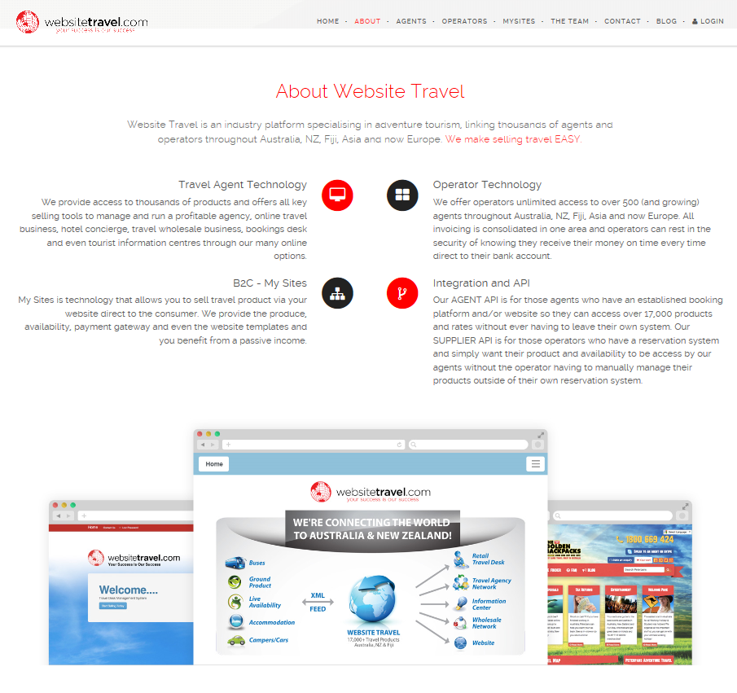
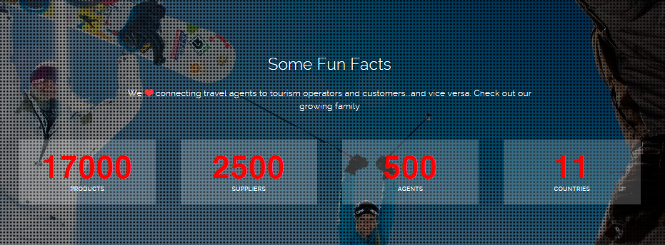

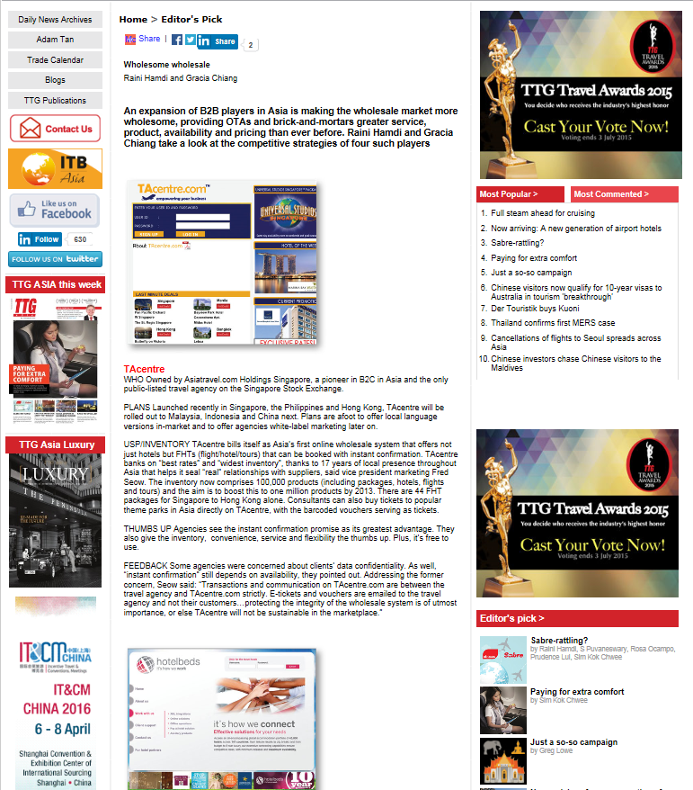
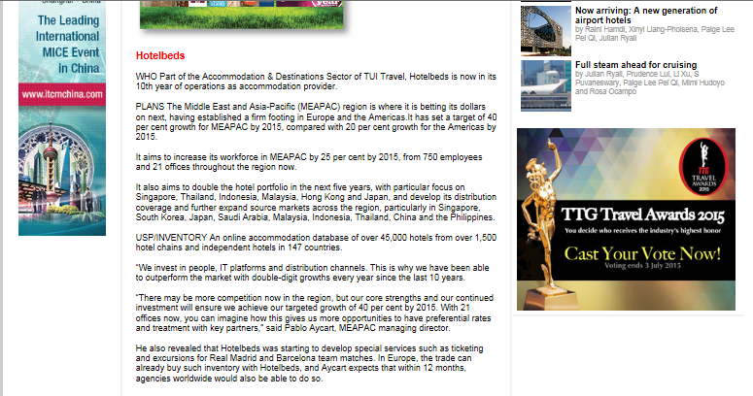

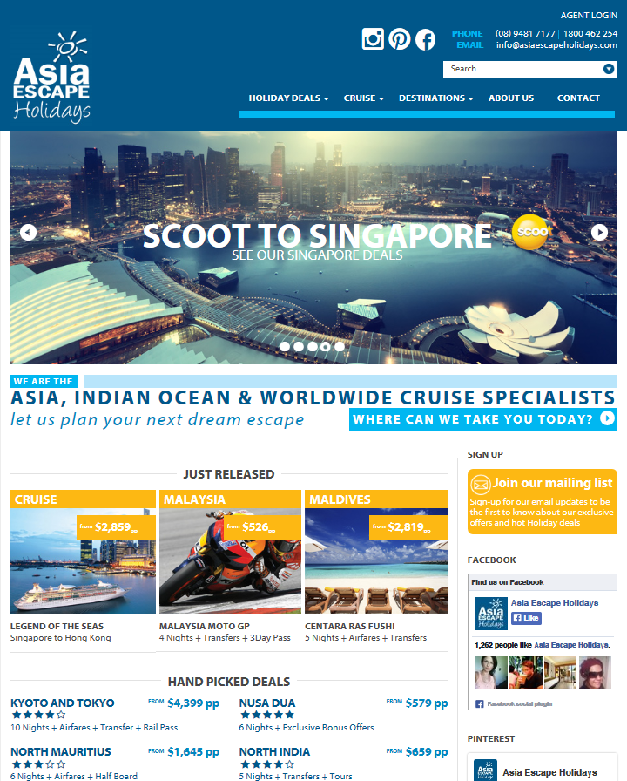
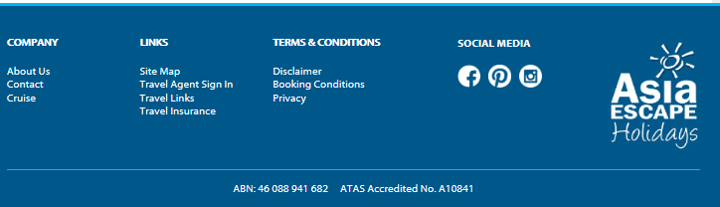

Tourism authorities
Tourism authorities provide information that can be a very useful resource to travel agents in providing local, regional or national information. They generally exist to promote the destination and not to sell specific products and are usually government funded. Examples of tourism authorities for ASEAN nations are listed below.
The type of information that they can provide would include:
- Maps
- Destination and city guides
- Festivals and events
- Suggested itineraries
- Photo galleries
Visit:
http://www.aseantourism.travel/
http://www.bruneitourism.travel/
http://www.tourismcambodia.org/
http://www.indonesia.travel/
http://www.tourismmalaysia.gov.my/en/intl
http://itsmorefuninthephilippines.com/
http://www.yoursingapore.com/en_au.html
http://www.tourismthailand.org/
http://www.vietnamtourism.com/

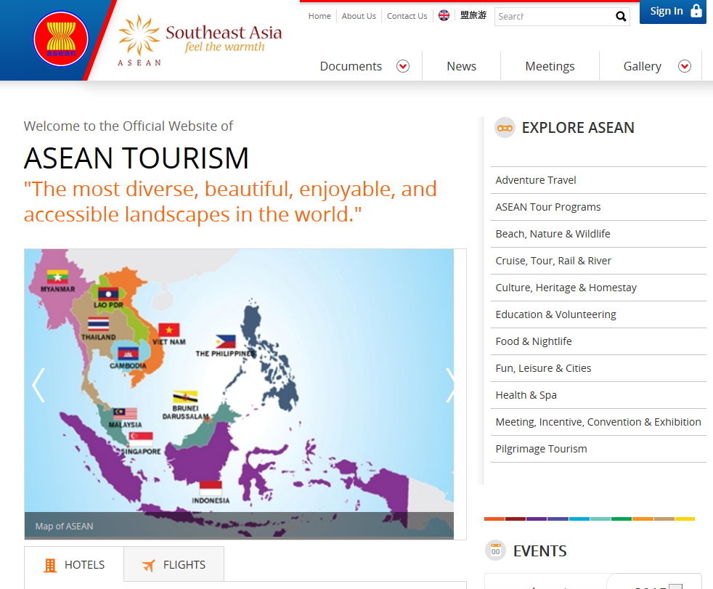
After you have determined the information needs of your client, the next step is to source and access the information. There are many sources of information available to travel industry employees and the task of finding the most useful and reliable source can be overwhelming and time consuming.

Intranet (company designed information system)
An intranet is a private computer network that uses internet technology. It is used by an organisation to share information with its employees. It contains information specifically related to employees and the organisation and also has links to recommended websites.
Generally the home page is accessible to all staff. If there is any secure information that is not available to all staff, a login may be required.

Employee information
The following is a screen shot of the William Angliss Institute home page. This page appears after staff first log into their computer and each time staff open Internet Explorer. Note that the home page contains general information for all staff under the categories of Employment Opportunities, Angliss News and Learning & Development. This information is updated daily.
Down the right hand side are links to other general information including Staff Directory, Policies & Procedures and Forms & Documents. Across the top of the screen is a toolbar for different departments within the Institute including Corporate, Teaching & Learning and Human Resources.
The home page allows staff to link to a huge range of information through a variety of different links.

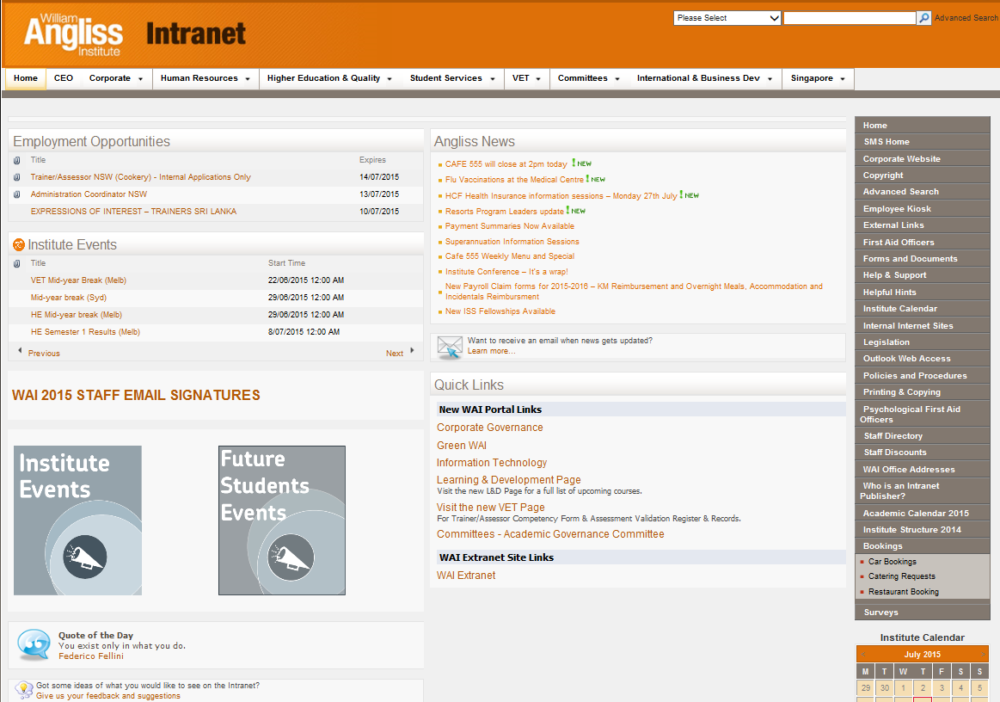

Company information
There are many benefits in having an intranet site, for both the organisation and employees. The organisation can ensure that employees are accessing information from reliable sources and that information provided from store to store is consistent. For the employees, the intranet site can be a ‘one stop shop’ of information and saves a lot of time. It also gives the employee confidence that they are sourcing and accessing information including preferred suppliers of the organisation and recommended websites.
An intranet home page for an organisation in the travel industry may have links to information on visa and health information, brochure ordering, airline agent sites, preferred supplier websites and destination information.
It is much easier to become familiar with your company’s intranet page than it is to remember all of the different websites.

Delicious
Delicious is a ‘social bookmarking’ site. It allows you to save a list of useful websites. You can give the web address a name (a bookmark) and also categorise the information (using ‘tags’). You can also share this information with other registered users and find useful websites through them.

Computer Reservation System (CRS)
It is worth remembering that a CRS (e.g. Galileo, Sabre or Amadeus) contains a lot of information in addition to flight schedules and pricing.
The CRS is an extremely fast and efficient way to find out basic information such as:
- Time differences
- Travel distances and flight times
- City and airport information
- Airline information

Activity 3
NOTE: It is a requirement of this unit that you attempt this Training Activity.
- List four different types of information you are able to access from your CRS.

- Access your organisation’s intranet home page to see what information is available for you.
- List three examples of information for employees of the organisation.

- List four examples of information provided for clients of the organisation.

Activity 4
NOTE: It is a requirement of this unit that you attempt this Training Activity.
“I want to find out which domestic tour wholesalers are promoting their products on the web and what they are promoting” says your Manager. He/she needs the information in an hour for an important internal meeting. Source and print the information, with a very brief summary of what you have found.

1.4 Identify the functions of an automated information system

Introduction
A central reservation system (CRS) is the most common system used today by travel agents as it is the most reliable for ensuring information is always current. The next most popular system to use is the internet. Whether you are using a CRS or the internet you will need to be familiar with the functions and basic operation of the system to enter and retrieve information and search for and complete bookings for clients.
Each reservation system will have different features and functions and you will likely be required to undergo training before use in a commercial environment. Following is the index from the Galileo training handbook identifying system functions. Excerpts from the handbook are included to identify procedures associated with the function and to provide you with an indication of how information is displayed to the operator. Galileo enables the operator to book flights on any airline worldwide. It interfaces with hotel and car hire booking systems enabling multiple bookings to be completed through the one site.

Central Reservation System (CRS)
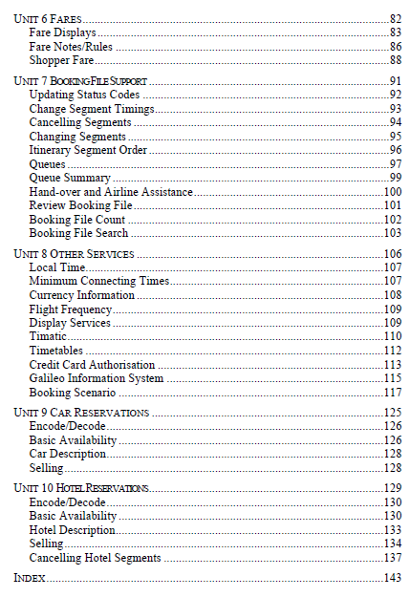
The complete Galileo training handbook is available for viewing by asking your trainer

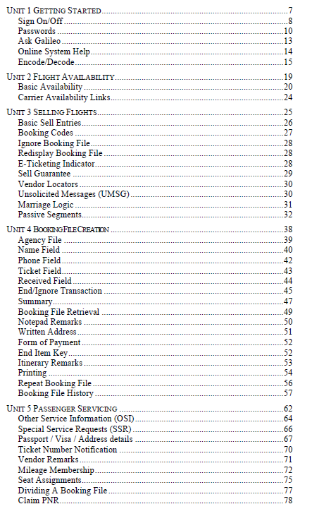

Fare Display Screen Description

Fare Displays
For help enter: H/FD
Galileo 360 Fares is the Galileo fares system available to all Galileo agents.
This section is only a brief introduction to the Fares system.
FD30NOVSYDBKK Fare display SYD/BKK- 30NOV.
FD1ØSEPLONAMS/BA Display by date and carrier.
FD1ØNOVSYDHKG-RT Display return fares only.
FD19SEPSYDLON-OW Display one way fares only.
FD8JULAKLMEL@F Display for first class fares only.
FD1JUNDRWSIN∗CNN Display for child fares only.
FD15OCTSYDSIN*ITX Display IT (holiday fares).
FD27JANPERSIN@C/SQ Display fares in C class with SQ.

1. Boardpoint, Offpoint, Day of week, Date of travel, and Carrier.
2. MPM – Maximum permitted mileage & Global Indicator.
3. Stop Press information, use FC* for full information.
4. Type of fares displayed, Adult, Child, Infant.
5. Other types of fares that are available for this city pair.
Use FD*(Code) to view.
6. Line number.
7. Fare indicators X Fare not available for Auto Fare quote.
@ Fare/rules subject to change.
8. CX Carrier code, no code indicates standard IATA fare level.
9. FARE Fare in currency of board point, from lowest to highest.
R indicates return fare level.
10. FARE BASIS Fare basis code.
11. C Booking class code.
12. AP Advance purchase lead in time,
21 21 days before departure,
++ Refer to fare rules for details,
1+ 1 day after reservation, refer to rules,
@@ No details held, refer to rules.
13. MIN/MAX Minimum and Maximum stay conditions.
The minimum stay requirements are shown as a number of days, or
SU indicates the Sunday rule applies
V indicates the stay is variable
W indicates the stay is one week
The maximum stay is shown in number of days (eg.90),
months (eg.3M), or 1 year (eg. 1Y).

14. SEASONS May be preceded with;
O indicates Outbound journey must be commenced during the period shown.
I indicates Inbound journey must be commenced during the period shown.
No entry preceding a date indicates both the Outbound and Inbound journeys are permitted during the period shown.
A 3 character month code may be followed by a single numeric (eg. 15JAN7) which indicates the year (eg 7 = 1997).
15. MR Mileage/Routing indicator
M Mileage fare
R Routing fare
MR Mileage & routing conditions apply.
16. GI Global indicator.
17. DT - Date/Time restrictions.
D Date restrictions apply
T Time restrictions apply
F Flight restrictions apply

Review Booking File
For help enter: H/RB.
Review Booking File allows you to diarise booking files by placing a Booking
File onto a specific queue for a specified date and time. eg. Chase Documents.
Create
RB. Ø1MAY / 11ØØ / Q42 ∗ CHECK DEPOSIT (optional free text)
Queue Number (optional-will default to Q12)
Specified time for queue placement (optional)
Date for queue placement (optional-will default to today’s date)
Function Identifier (mandatory)
Other Examples
RB.Ø1MAY/14ØØ/Q35∗CHECK VISA BEFORE TICKETING
Booking to appear on 1 May at 14ØØ on queue 35 to check Visa.
RB.Ø6JUN/11ØØ/Q35∗CHECK VISA/Q43*CHASE PAYMENT
RB placed on 2 queues with different messages.

RB.13SEP∗SEND CNF LETTER
Booking to appear on 13 Sept on default queue 12 to send confirmation letter.
Change/Delete
RB.2@Ø7NOV/Q37∗TEXT Change 2nd Review Booking item.
RB.3@ Delete item 3.
RB.2-7@ Delete items 2 through 7.
RB.ALL@ Deletes all item.
RB.@2/15JUL Change the review date of RB item 1
keeping all other details unchanged.
NOTE: A review Booking File can only be set for queues 12 and 26
through 99. A maximum of 10 can be added to any Booking File and must be for a date prior to the last flown flight.

Booking File Search
For help enter: H/LD
It is possible to count and bounce Booking Files to a queue that meet certain
search requirements. This is very useful in the case of airfare increases, strikes,
consultant going on leave or leaving the company.
Basic Request
LD/ALL/28DEC-D Display list of ALL Booking Files that
have air segments with a travel date of 28
December.
LD/TKT/1APR*15APR-Q/8Ø Queue TICKETED Booking Files that
have air segments with a travel date
between 1 APR to 15 APR to queue 8Ø.
Options
/ALL All Booking Files regardless of ticketing status.
/TKT Only Ticketed Booking Files.
/UTK Only Unticketed Booking Files.

/BA By airline.
/QF.BA.NZ Multiple airlines (maximum 5).
/BMEL By Board Point.
/DBKK By Destination.
/S-SB By consultant Sign-on initials.
/23DEC*1ØFEB Date Range.
Examples Using Options
LD/ALL/BMEL/QF.SQ/1OCT*4OCT-Q/34
Bounce all Booking Files with air segments with a board point of MEL with carriers QF and SQ that depart between 1 and 4 October to Queue 34.
LD/UTK/S-DG/19MAR*3APR-Q/9Ø
Bounce all Unticketed Booking Files with travel dates between 19 Mar and 3 Apr that were created under the sign on code DG to Queue 9Ø.

Booking File Retrieval
 For help enter: H/∗-
∗-JONES Retrieve by Surname.
∗1 Display from Similar Name List.
∗L Redisplay Similar Name List.
∗3WG6BD Retrieve by Galileo Record Locator.
∗∗B-KING/JMS All branches, by name

SSR System Prompts
Many SSRs that allow free format text have prompts to ensure relevant
information is generated to carriers so that the SSR can be actioned correctly.
In the above Unaccompanied Minor request Galileo has responded with a prompt advising the information that should appear in the free format text. If this information was in the free format text when the input was initially made, display the record and continue with the booking.
eg: SI.UMNR∗ENGLISH MURIEL 8YRS FEMALE SENDER MR
BOB HISLOP COCONUT WAY DOLHPIN SPIT WA PH PER
988 4Ø22 RCVER MRS SUZIE WANG APT3 24 ORCHARD RD
HONOLULU PH HNL 433 9Ø99
IMPORTANT NOTE: Due to system limitations QF does not use the above format for Unaccompanied Minors (UMNR). To send UMNR details to QF you need to send 1 SSR with the childs age, then 2 OSI’s - one detailing the sender details and one detailing the receiver details.
Please contact QF for further information

Hotel Reservations
RoomMaster provides Galileo agents with availability and descriptive information on over 45,000 hotel properties worldwide. RoomMaster also provides the user with the capability of booking space at these properties. In most cases instant confirmation is received from the hotel’s own reservation system.
Hotel chains input property-related data and rate information directly into RoomMaster. This optimises the quality of information and provides you with accurate, current displays.
Encode/Decode
GC∗11/HTL/HILTON Encode Hilton.
GC∗11/HTL/SP Decode Chain SP.
Basic Availability
 For help enter: H/HOA
With Air Segment
/2+HOA-3NT Hotel Availability for destination of segment 2 staying 3 nights.
Without air Segment
HOA12DEC-16DECSYD Hotel availability in Sydney for specific date range.
7. Rate status indicator
V Rates displayed are guaranteed to the agent by the hotel.
Blank Rates are not guaranteed and are subject to change.
Tax
T Tax is included in rate
Deposit/Guarantee policy
G Guarantee of arrival is required regardless of check in time
D Deposit required regardless of check in time
4 Hold till 4pm without deposit or guarantee
6 Hold till 6pm without deposit or guarantee
Location code
C City A Airport
R Resort S Suburban
D Downtown
8. Hotel Description
HOD... Prompt to display hotel description for line selected.
9. Address
Distance/direction of property from reference point
12E 12 km East of reference point
1NW 1 km North West of reference point
Transport indicator code
L Limousine B Bus
C Courtesy car W Walk
P Public transport O Other

Car Reservations
CarMaster provides Galileo agents with availability and descriptive information for over 18,000 rental locations worldwide. CarMaster gives you the ability to book cars and, in most cases, an instant confirmation is received from the car vendor’s own system. Car vendors also update information in CarMaster, enabling you to access current, accurate displays.
Encode/Decode
GC∗12/CAR/HERTZ Encode Hertz.
GC∗12/CAR/ZT Decode car company ZT.
Basic Availability
 For help enter: H/CAA
With Air Segment
/2+CAL-12FEB/DT-0900 Request Car Availability after air segment 2 with a return date of 12 February and a drop time of 0900.
Without Air Segment
CAL12OCT-15OCTLAX/ARR-12ØØ/DT-16ØØ
Request Car Availability in Los Angeles for specified dates with a pick up and drop off time.
NOTE: Pick Up (ARR) time is mandatory if no air segment is present, the Drop Off (DT) time is always mandatory.

Screen Description
1. Location Indicator
T Terminal (airport)
O Off terminal (airport)
2. Car Codes
Car Size Car Type Transmission Air Con.
M - Mini B - 2 door A - Automatic N - No
E - Economy C - 2 or 4 door M - Manual R - Yes
C - Compact D - 4 door
I - Intermediate S - Sports
S - Standard T - Convertible
F - Full size X - Special
P - Premium F - 4 Wheel Drive
L - Luxury L - Limo
X - Special R - Recreation
V - Van
W - Wagon
3. Status
- Car Type not in Fleet
S Sell
N Need
R Request
C Closed
4. Paging
CAA∗PD Page Down
CAA∗PU Page Up
CAA∗PR Page Right
CAA∗PL Page Left

Car Description
 For help enter: H/CAD
For more information about a car location, a description can be displayed from the availability screen.
CADB1 Description for location in column "B" of availability (use any line number).
CAD/CARS Request item CARS from description menu.
CAD/AGE+3+DROP Display Keywords using word or number.
CAD∗PD Pages down to additional information.
CAD∗MENU Return to description menu.
CAD∗R Redisplay last active menu.
CAA∗R Redisplay availability

Internet

Exploring the Internet
The Internet is a worldwide collection of computer networks, cooperating with each other and exchanging data using a standard software system. The internet connects through telephone wires and satellite links and was revolutionized with the creation of fibre optics, which allowed for the massive leap forward in internet technology.
Internet users can share information in a variety of forms. The size, scope and design of the Internet allows users to:
- Connect easily through ordinary personal computers and other personal devices
- Exchange electronic mail (E-mail) worldwide, nearly instantaneously (if using a strong system including broadband) via accounts on the Internet
- Access, review and create information for others to access, thus increasing the knowledge available to the average person
- Access multimedia information that includes sound, photographic images & video;
- Access diverse perspectives from around the world.
An added bonus to the Internet is that it lacks a central authority, meaning that governments, corporations or individuals can not actually control it. This means that information cannot be hoarded away or hidden by “gatekeepers” of knowledge, as can happen with other forms of information. For example, if you are not allowed a library card, you could not borrow a book to read from your local library! Various governing boards & bodies do work to establish policies and standards to make the Internet respectable and to impose sanctions on people who use it inappropriately.
The easiest way to think about the internet is to imagine it as a living library with no walls, floors or roof. It will never actually become full as it is ever expanding, constantly growing with new websites (books) and webpage’s (pages in the books). The vastness of the internet is truly astounding and the amount of information stored on the present day internet is virtually uncountable. Whatever you would like to know about, you can probably find it if you know how.

Challenges on the Internet
However, now that you are aware of the internet and what sorts of things it does, there are two main challenges that you will need to understand or overcome when using the internet. These two challenges are:
- Knowing how to find things (search engines are the best option)
- Understanding that just because you did find it on the internet, it may not be truthful, accurate or even real!

Internet Explorer
Microsoft Internet Explorer is a common “web browser”. This is a program that is designed to connect to the internet and allows you to search or “surf” the internet, looking for information, communicating with friends or just searching around for something good to look at. To start using this program, go to the start menu and select either the “internet explorer” icon (it is the blue letter “e” with a band running around it) or select the all programs menu and find internet explorer in the list of programs displayed.
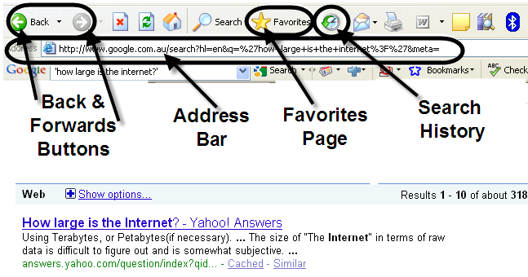

Address Bar
The address bar is the white rectangular bar that shows at the top of the page. This bar is showing the web address of the current webpage being displayed in the web browser. Every different webpage on the internet has a unique web address. As you can see, they are often quite large and complicated. The chances of you constantly being able to type in the web address perfectly every time for every page you ever visit is not high, so there are several different ways for you to keep track of where you have been and to be able to navigate back there if required. You can also copy and paste addresses into and out of word, excel or emails, to help others find pages or for you to find your way back to them at a later date.

Forward & Backwards Buttons
The forward and backwards buttons (green arrow left & right, top left of screen) work in much the same way as they do in the other Microsoft programs. As you move from webpage to webpage, you have gone from the original forward to the new page. If you wanted to go back to the page you just left (even if it was an hour ago), you just need to click “back” on the browser. This helps in navigating through the webpage’s you have viewed recently.

Search history
However, it is not always possible to press the back button. For example, you may have shut the program and reopened it the next day. On the right hand side of the address bar, you will notice a small downwards facing black arrow. This indicates there is information for you to view. In fact, this will show you the recent “history” of where you have navigated using the browser. Also, there is actually a “history” button located at the top of your screen that will do a similar thing.

Favourites page
There is also a more permanent way to keep track of websites you have been to and may want to visit again in the future. This is the “favourites” option on your browser. The favourites icon looks like a large golden star on the top menu and when you select it, it will open a panel on either the left or right hand side of the window. Depending on the browser you are using you will be prompted to click ‘add’ or ‘done’ to include that web page in your ‘favourites’ file. You have the opportunity to use the name that automatically appears or you can change it to something you think is more appropriate.
For example:
- Have open on your screen the page that you would like to directly return to in the future
- Type (Ctrl+D) – this will bring up a box titled ‘Add a Favourite’, here you can type in a name for this site or accept the site name as listed – e.g. ‘Currency Converter’ or ‘Smartraveller’. See example below
- Click ‘Add’ and this will add this site to your list of Favourites.
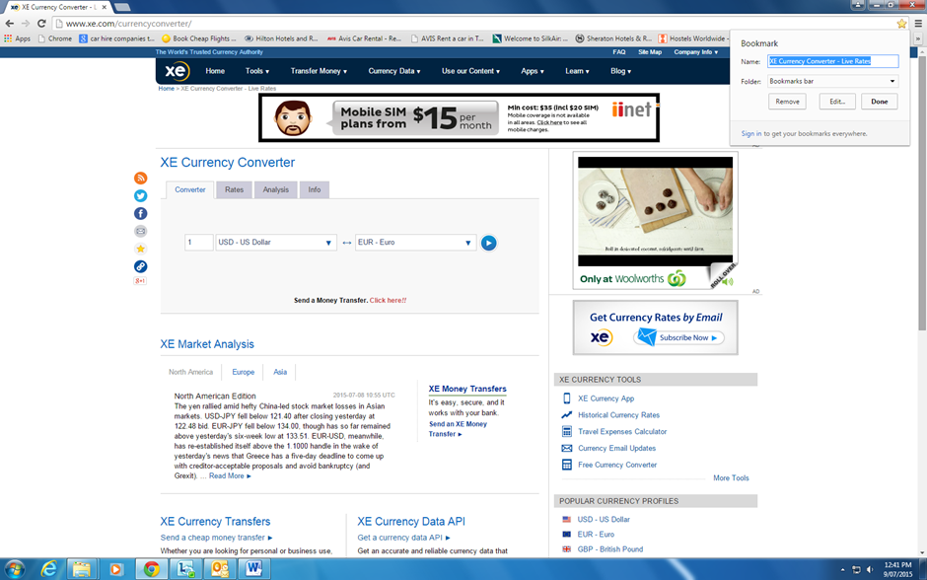
Below is an example of a bookmark reference page using Google Chrome allowing for easy access to regularly visited sites.
You will need to be familiar with the system software application you are working on as they are not all the same.

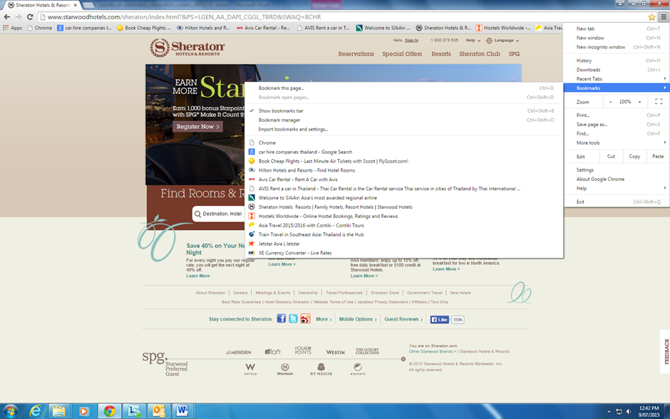
Following is the bookmark list as displayed by Explorer.
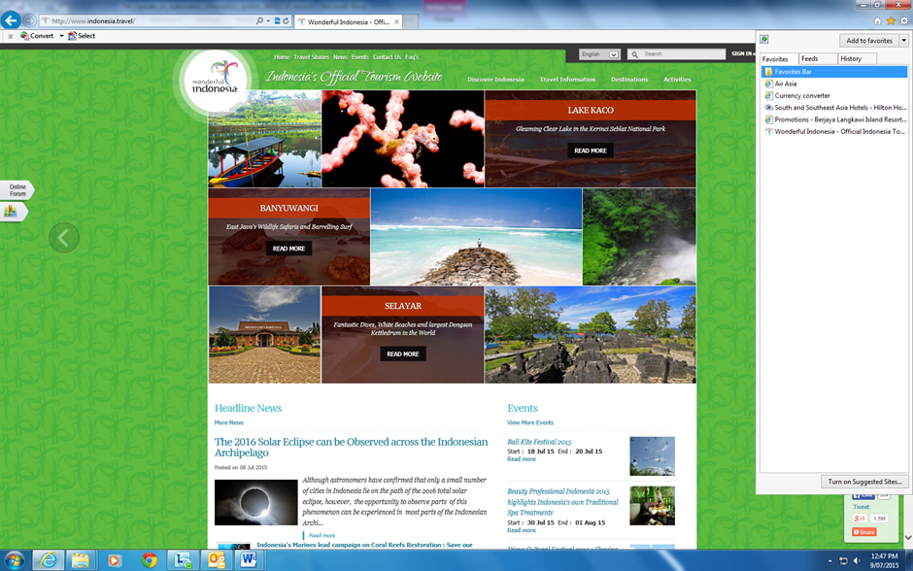

To access your list of Favourites at any time you can either type (Alt+C) or click on the small icon with the gold star.
It is possible to save your favourite websites so that they can be accessed from any computer. Have a look at the website www.delicious.com as an example.

Search Engines
There are several programs within the internet that can help you to find things that you want. These programs are called “search engines” and the most common ones are Google, yahoo, windows live and ask. There is also an even bigger (or maybe smarter) search engine named metacrawler that searches within those other four search engines! The search engines require a search term or phrase, which they then try to match with the criteria you select. The engine searches through the webpage’s on the internet and selects the most accurate matches and lists them in order of relevance. If you type in a very broad term, it will gather many results but you may have to search through a lot of results to find the ones you want. Therefore, you need to refine the search by using more specific terms or limiting the engine, for example by selecting only pages from your own country or region instead of worldwide.

Hyperlinks
There are several ways to navigate around webpage’s and one of the easiest is the use of hyperlinks. Hyperlinks are represented on the screen as text, buttons and sometimes even images. You can usually identify a hyperlink through the way it looks, for example, many are coloured blue and are underlined. However, sometimes it is hard to identify them, so a second method is useful. If you hover your cursor or icon over something, and the icon remains the same shape, it is not a hyperlink, however if your icon changes to a small hand with the pointer finger pointing, then that is most likely a hyperlink. If you left click your mouse button while on that link, you will navigate to that webpage. Also, when you hover you icon over a suspected hyperlink, it will show you the web address in a small pop up dialogue box.

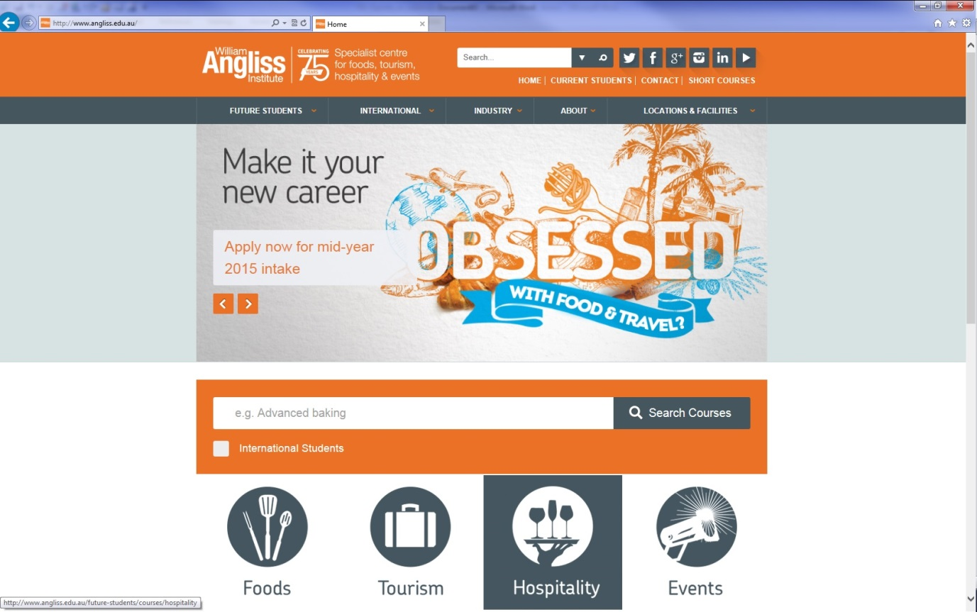

Hyperlinks

New Window
Sometimes when you navigate away the browser will either automatically open in a new window or it will ask you if you would like to open in a new window. The choice is not always yours and your decision will depend on whether you want to view the two windows at once. Remember, you can always swap windows, or minimize one to view the other and vice versa.
Activity 5 Internet Search
NOTE: It is a requirement of this unit that you attempt this Training Activity.
Try to answer these questions by using a search engine (e.g. www.google.com.au). Try practicing using shorter key word searches, instead of typing the whole question into the search engine. Place your answer & the website you found it on in the spaces provided.
TIP: Copy & paste the website address directly off the webpage (found in the "address bar") straight into your document!
No. | Questions | Answers | Website
1 | What is the capital city of Vietnam?
2 | What is the national sport of Thailand?
3 | When is the Water Festival in Cambodia and what is it about?
4 | I want to go to the Great Lantern festival in the Philippines. Can you tell me about it?
5 | Which SE Asian countries conduct a marathon?
6 | When is the Dragon Boat Festival in Penang?
7 | I am a Grand Prix fan. Where and when are they held in SE Asia?
8 | Name the three largest countries in SE Asia?
9 | Is it possible to travel by train from Johor Bahru to Mandalay?
10 | I have a one night stopover in Brunei. What could I do?

My Computer
The my computer function allows you to enter the file structure of the computer. You can locate the my computer shortcut icon on the main screen after starting the computer. Double left click your mouse on the icon to open the view displayed below. From here, you can view the hardware or actual components of the computer. Your computer will have a local disk (C:) which is the primary hard drive. It will also have a DVD RAM drive (D:), a network drive (L:) and any other drives attached. When you insert an external disk drive like a USB stick, it will also appear in this screen. These items must not be altered or destroyed. They hold the files and programs, which can be altered, added or deleted by you. The files and programs are held in folders.
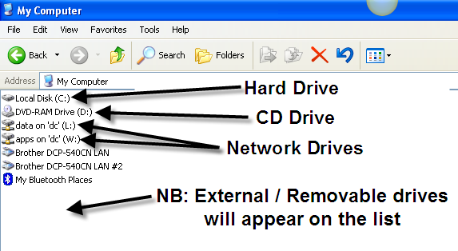

File folders
A file folder is much like a folder in a filing cabinet. Folders are identified by a small icon that looks like a manila folder. File folders are stored on the hard drives or external disk drives. Below you can see an example of what the file folders on the C:\ look like. You can see which drive or folder you are looking in by locating it in the address bar:
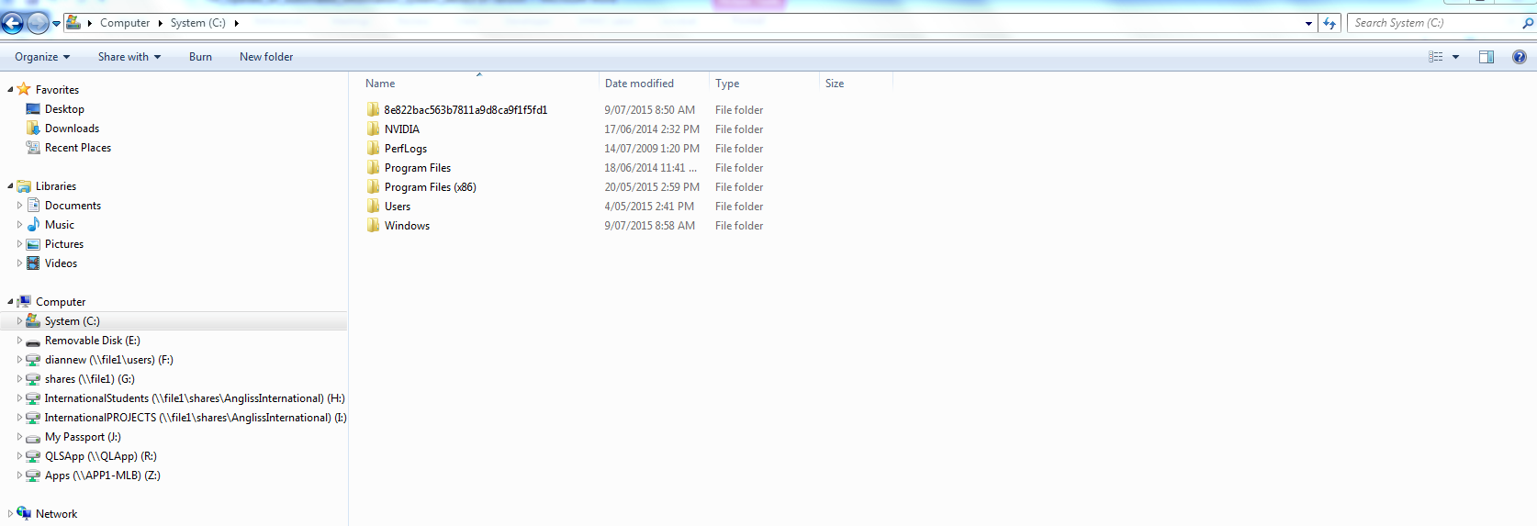

Files
Actual files are contained within file folders and can be identified by their different file icons and file extensions. For example:
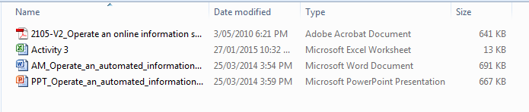
You can also identify files by the way they end. For example word files (end in .doc), excel files (end in .xls), PDF’s (end in .pdf) and an image (end in .png)

File naming
Files can be named anything that you like however it is good practice to name them in a way that identifies them to you or other users of the computer. Naming assignments “Task 1” might seem easy at the time but when you have thirty files all named the same, things will become difficult! Name your files in a way that makes it easier for you later. For example, you might label your file “Op Auto Info System assignment 1”. When you name files using the “save as” function within programs, the system will automatically add the file extension.

Changing file names
At any stage (as long as the file is not currently open) you can change the name of a file. To do this:
- Hover cursor over filename
- Right click to bring up the menu
- Select the "rename" option
- The filename will become highlighted blue. Carefully position the cursor again, left click once and type in the new filename
- NB: Be careful to keep the file extension at the back of the filename, including the doc, xls, pdf, png, (e.g. newfile.doc).
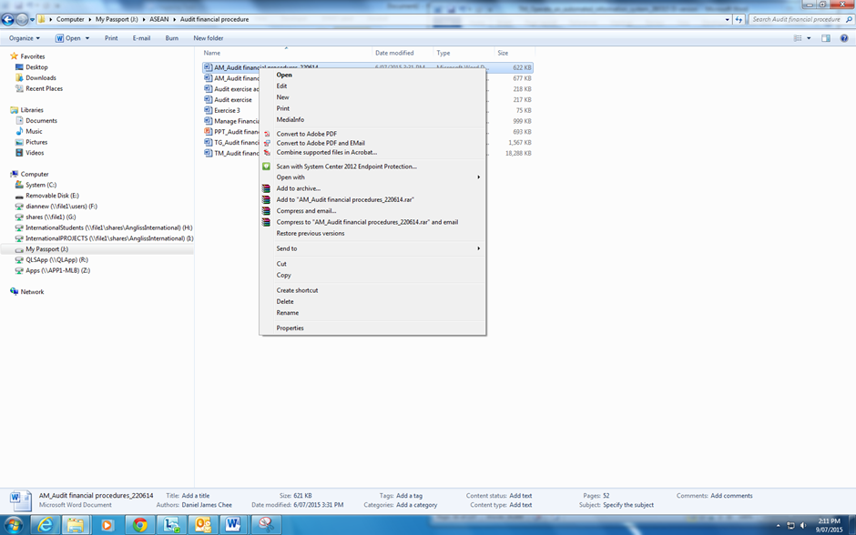

Minimize, restore & close windows
There are three basic operations when dealing with the windows, either to have them active (restore), to minimize them so we can work on another program or window or to close them when we have finished using them: Below is an explanation of what icons to use to complete these operations.
Minimize, Restore & Close Windows
Button | Icon | Example
Minimize |  | Clicking on the small _ icon in the top right corner of the screen will minimize the window, which will appear to "shrink" into the bottom of the screen.
 |  | To bring this window back to full screen, left click once on the window tab at the bottom of the screen.
Restore |  | Clicking on the small double square icon in the top right corner of the screen will alternate the window from "full screen" to a smaller version.
 |  | The smaller version of the window allows you to manipulate the size and shape of the window. Hover your icon on the border of the window and you will notice a double ended arrow icon appear. Left click and hold, then drag the window to the desired size and shape. Diagonal operations from one corner of the window will keep the window in perspective or scale.
Close |  | The small X icon will close the active window. The larger red X icon will close the entire program.

Typing tips!
The keyboard basically resembles a typewriter, with a few additions. Below you will find several images of the Lenovo Keyboard we are using in our computer lab. Certain keys have been labelled with a brief explanation for your convenience.

Left Hand Side of Lenovo Keyboard
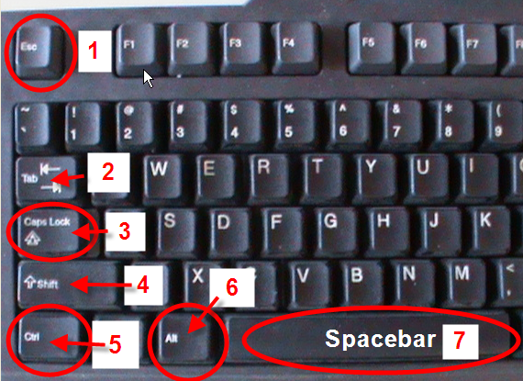

Right Hand Side of Lenovo Keyboard
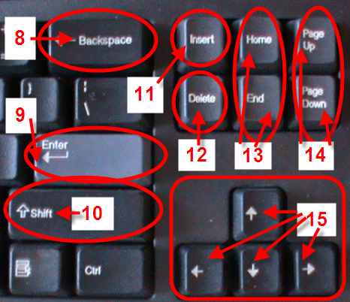
Work Projects
It is a requirement of this Unit you complete Work Projects as advised by your Trainer. You must submit documentation, suitable evidence or other relevant proof of completion of the project to your Trainer by the agreed date.
1.1 Please complete the following activities relating to this Performance Criteria:
- Activities 1
1.2. Please complete the following activities relating to this Performance Criteria:
- Activities 2
1.3. Please complete the following activities relating to this Performance Criteria:
- Activities 3, 4
1.4. Please complete the following activities relating to this Performance Criteria:
- Activities 5

Summary

Identify the context for use of an automated information system
Identify a range of information systems and sources in use within the industry
- Central reservation system:
Sabre
Amadeus
Galileo
- Product database and suppliers
- Automated information systems
- The Internet
- Tourism board
- Festivals and events calendars
- Newspapers
- Pamphlets/brochures.
Describe policies and procedures for operating an automated information system
- System access protocols, including levels of access, log-on and log-off protocols
- Access Controls
- Password Controls
- Licences
- Intellectual property
- Be aware of confidentiality
- Security and integrity of information, including premises security
- Storing of Files
- Prohibited Activities
- Legal considerations.
List information that may be available through an automated information system
Identify and select appropriate sources of information
- Information from third parties
- Tour operators
- Wholesalers
- Tourism authorities
- Intranet:
Employee information
Company information
- Favourites
- Computer Reservation System (CRS).
Identify the functions of an automated information system
- Central Reservation System (CRS):
Fare Display Screen Description
Review Booking File
Booking File Search
Booking File Retrieval
SSR System Prompts
- Hotel Reservations
- Car Reservations
- Exploring the Internet:
Internet Explorer
Address Bar
Forward & Backwards Buttons
Search history
Favourites page
Search Engines
Hyperlinks
New Window.

Element 2:
Access information using an automated information system

2.1 Identify information requirements

Introduction
The information requirements of your customer will depend on a range of different factors including where they want to go, who they want to travel with and what they want to do. You also need to find out how much knowledge they already have about their intended travel destination.
Some clients will come to you with very clear expectations of what they need while others will be very unsure about what it is they want. As there are so many factors involved in why, where and how people travel it means that the range of information you may need to access may be very broad. Although this can be extremely challenging, it is also what makes the job so interesting. Keep in mind that it is not only customers who may be asking you for information but also other colleagues, agencies or businesses or you may simply be aiming to clarify existing information for your own knowledge.
The types of information you may need to investigate may include:
- Pricing of products and services
- Availability
- General destination information
- Product information:
- Accommodation
- Transport
- Attractions
- Amenities
- Events and festivals.
Consider this example of very different clients wanting to travel to Jakarta. One is a business woman who frequently travels for meetings. The other is a young, adventurous couple traveling on holidays.
Each of these clients may need assistance with airfares and accommodation. It is likely that the business traveller will have specific dates and times that she wishes to travel. The young couple may ask you for advice on the best time to go, activities they can do, and so on.

Ask questions
When dealing with clients the best way to find out what information is required is through questioning. Asking questions and taking notes helps you to get a clear picture of what your client needs. Questioning is a great opportunity to learn more about your client and to build rapport. During the conversation you should take a moment to summarise and repeat back to your client what you have understood they need from you. Asking questions and then clarifying your understanding enables you to provide great customer service and also helps you to work efficiently.
Consider this example
A couple enters your travel agency and requests information on golf holidays in Malaysia. You do not have any brochures on this, so you need to source information on the internet. By questioning the customer and asking, say:
- Do they mean east or west Malaysia, or both?
- Do they have a particular town in mind?
- Do they prefer a guided golf trip?
You will be able to break the information needed down into more detail.

Qualifying what the customer wants
A sales person needs to understand customers sufficiently well to match their needs with just the right product or service. They need to find out what a potential customer wants.
The term which is used to describe how we find out what customers want is qualifying. It means asking and probing for more and more information until a more detailed profile of the customer’s needs, and possible solutions for meeting them, begin to form in our minds.
As someone working in the tourism industry, you are, indeed, a sales person and need to remember that the requests for information you will get is the beginning of a sales opportunity.

Using sales skills
The professional sales person determines customers’ needs by skilful and effective use of questioning, listening and responding.
To be that successful sales person in tourism you need to:
- Ask your clients questions
- Listen
- Develop empathy (putting yourselves in their position), rapport (creating a good relationship), and trust.
This helps you to determine what the customer wants so that what you are selling (through the information you are providing) is directed to the customer’s needs.

Types of questions
To help you qualify what the customer wants, you must:
- Ask open questions, and
- Avoid closed questions.
A closed question requires only a yes/no answer.
For example: ‘Do you like playing golf?’ (Answer: yes/no)
An open question, however, usually begins with the words:
How, Who, Why, Where, What or When
For example: ‘What is it about playing golf that appeals to you?’
The answer you hear from the open question is much more likely to tell you what this customer likes and is looking for. It might help you to sell a golf day trip and, say, a walking tour or outdoor hike in the mountains.

Continuing qualifying questions
Qualifying what a customer wants does not always mean just asking simple questions and receiving direct answers.
People will usually approach you looking for information. They are often not clear or yet sure of what they want when giving you details in answer to your questions on, for example, dates, destinations, lengths of stay, and other key information.
One of the proven techniques to help you qualify customers looking for information is:
Don’t give all your information first. Continue to ask qualifying questions.
A frequent mistake made in a sales context is to give too much information without getting enough in return to complete the sale.
This applies just as much to handing out brochures or quoting hotel rates or giving information on golfing holidays.
Wait until you have gained all the information you need before you make a professional recommendation.

Activity 6 – Access information
NOTE: It is a requirement of this unit that you attempt this Training Activity.
1 What general information may a client require about a destination?

2 What kind of information do you think a client may need about the following products?
Accommodation:

A cruise:

A flight:

2.3 Apply search techniques to locate identified information

Introduction
Once you have determined what information you need to access, you will need to make a decision on where to start looking. Sometimes there may be only one logical choice on the best place to look – for example using your Computer Reservation System to search flights. Other times, there may be a range of options and you may not be sure where to start.
Whether you are looking for general information or specific details from wholesalers and tour operators, you need to consider the reliability and reputation of the information source.
You may choose to work with a ‘preferred’ supplier. These are suppliers with whom your organisation has an established relationship and you can confidently access information and sell products from these companies. You will most likely have their brochures displayed in your store and if your organisation has an intranet site, it may have a link to preferred supplier websites. This is a great place to start looking for information.
If you are trying to find general travel information it is not a good idea to just do a general search through a search engine such as Google unless absolutely necessary. Firstly consider any other sites that have been recommended to you that you are confident will have reliable and up to date information. The problem in searching generally and not knowing your information source is that you cannot be sure that the information is current and accurate. For example, information on local transport, activities and so on may no longer be current or hotel information and ratings may only be based on someone’s personal opinion.
Experience will help you to make decisions on where to start your search. When you are starting out in the travel industry you need to take the time to look at your available resources, particularly brochures and preferred supplier websites. It is also a good idea to get an idea of the clientele you may be dealing with frequently so you can anticipate what their information needs may be and perhaps prepare a list of useful resources to use in the future.
When looking for accommodation, tours, and so on, you may find that there is more than one preferred supplier who will have the information you require. If you are trying to find the best price for your client, it may mean that you need to check more than one source of information so that you can confidently provide your client the best price you can. Again, familiarity with how to access and search through frequently used online information systems will make this a much simpler and time efficient task.

Selecting search methods
From this point on, we will presume that you have selected the Internet as your automated system. Having selected your system and identified possible sources of information (websites in Malaysia for example), you need to select appropriate search methods for the type of information you are trying to gain for your customer.
To use the internet for your information gathering, you therefore need to decide which search engine to use. There are well known global search engines and then there are smaller, local engines that may exist as well.
According to the following website http://www.ebizmba.com/articles/search-engines.

The top 5 most popular search engines are:
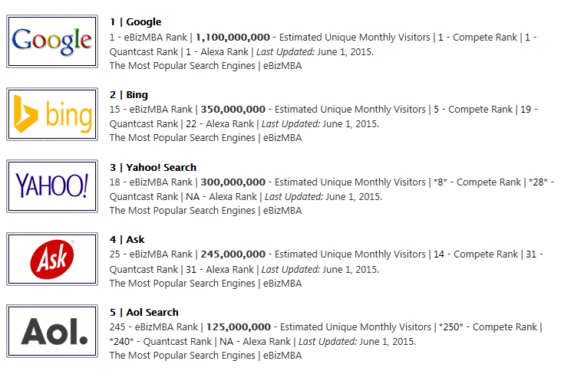
Making a query through the search engine
What is a ‘query’?
It is a request for information from a search engine.
A query consists of one or more words, numbers or phrases that you hope you will find in the search listings.

To make a query:
- Find the search engine’s search box.
Enter Query Here SEARCH
- Type some key descriptive words into the search engines’ search box.
Cooking tours Vietnam SEARCH
- Then click on the search button or press the Enter key on your keyboard to see your search results.
- A new window will open with the search engines’ results page for the search on the words you typed in. The results include links to pages that match your query.
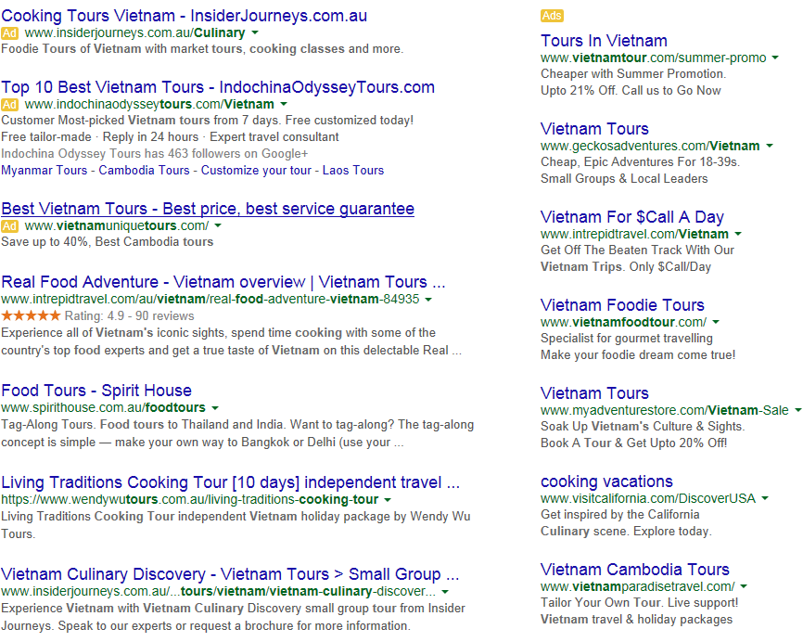
The results page will be full of information and links, most of which will relate to your query. Results that the search engine consider to be the most relevant to your query are shown first. Usually, ‘sponsored links’, which are paid advertisements, appear to the right of the search engines results.
The first line in each result is the page title, in blue.
The title will be underlined because it is a direct link to the web page. You can click on the title to view that page.
Under the title are often extracts from the web page that is linked to the title. These will include one or more of your query words shown in bold typeface.
The web address is shown in green, near the end of the result.

Activity7 – Search engines
NOTE: It is a requirement of this unit that you attempt this Training Activity.
Use three different search engines and compare results
Search engine used_______________________________________________________________
Search for ‘budget beach accommodation Thailand’. List the below details, for the first result you get.
Page title:
What page extract is listed?
Web address:
Search engine used_______________________________________________________________
Search for ‘budget beach accommodation Thailand’. List the below details, for the first result you get.
Page title:
What page extract is listed?
Web address:
Search engine used_______________________________________________________________
Search for ‘budget beach accommodation Thailand’. List the below details, for the first result you get.
Page title:
What page extract is listed?
Web address:

Using key words and phrases
Now you know how to use a search engine, you will be more efficient in making queries if you use key words and phrases to search for the information required.
The search terms and the order in which you enter them into a search engine affect both the web pages that the search engine finds and the order of your search engine result.
So when using a search engine, keep the following in mind:
- Use the words likely to appear on the pages you want; i.e.—Singapore Car Hire; Brunei cheap hotels
- Avoid using a question as a query. For example, the query ‘Does Hanoi have a Hilton Hotel’ instructs the search engine to find all these words. Such a query won’t necessarily find pages answering your question. A better, or more effective, query may be ‘Hanoi Hilton Hotel’
- When a search engine registers common words such as ‘where’, ‘do’, ‘I’, ‘for’ and ‘a’ it ignores them so that the engine can return more targeted results. It’s better to use a more precise term than a common one
- Does your query have enough specific terms; i.e. ‘Hanoi’, ‘Hanoi Hotels’, or ‘Hanoi Cheap Hotels’
- If you are searching for something that returns many different types of results, you should add a word that distinguishes them
- For best results, use a few specific words. For example, ‘Cheap Hanoi Hotels’ will return a better result than ‘List of Cheapest Hanoi Hotels with Swimming Pools’
- Search engines will usually recognise any spelling mistakes and suggest a more common spelling quickly. For example, if you enter ‘Kula Lumpor Luxury Hotels’ in error, the engine is likely to ask ‘Did you mean Kuala Lumpur Luxury Hotels?’ or simply provide a correct range of options in the search box. See below
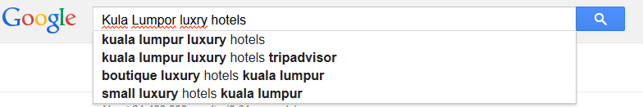

Activity8
NOTE: It is a requirement of this unit that you attempt this Training Activity.
Using key words in a search engine, find answers to the following questions:
- What is the address for the palace of the Sultan of Brunei?

- What are the opening hours of Singapore zoo?

- What is the name of the main international airport in Kuala Lumpur?

- What is the exchange rate for 1 Philippine peso to the Singapore dollar?

- What is the main form of transport between Myanmar and Malaysia?

Using system features
By now you have a good understanding of how to search for information by altering the order of key words or phrases in a search engine, but there are other things you can do to explore and fully use all the features and functions that search engines have.
An internet search engine has a number of features that will let you build on successful service queries, and search more deeply into the results you get back.

Refining a query
You can refine a query by changing or adding to the set of search terms you use. This will improve the return on the information you are looking for.
You can then get more ideas for refining queries in further searches by reviewing your results, including the extracts from pages the search returns and the web pages they are from.
For example, let’s say you are looking for information on car hire in Thailand for a corporate client who needs a limousine service. You could enter ‘Thailand Car Hire’, but many results will come back referring to general Thailand car hire. You would need to refine your entry by putting in ‘Thailand Car Hire Limousine Service’ as the search description in order to get the level of detail you want.
Activity 9 – Refining a query
NOTE: It is a requirement of this unit that you attempt this Training Activity.
Scenario – Refining a query
A customer requests information on beach accommodation in Thailand. She is travelling in a party of eight people and they can only travel in April.
Show in the space below a basic query to start the search for information for this customer, and then show one way in which you could refine the query.
Basic query
SEARCH

Refined query
SEARCH

Print screen the final results and attach it to this activity and hand in to your trainer.

Decide social media platforms to be used
As seen in the previous section, there are numerous social media platforms that can be used, each with their own advantages and disadvantages.
This section will identify the most popular media platforms commonly used in most social media campaigns.
Facebook

Facebook is the most popular social network website. Users of Facebook need to establish a profile where users can add information to describe themselves. Facebook does not limit the number of accounts a single user can establish.
Twitter

Twitter is the most popular of all social media micro-blogging sites.
It allows users to post messages of up to 140 characters in one posting. These posts can include quotes, personal thoughts, news and picture links and product and service links. While most users will establish a Twitter account initially to follow others, Twitter has quickly become the fastest way for information to spread around the world. Hence it is often preferred by businesses.
LinkedIn

LinkedIn is a social networking site aimed toward businesses and business professionals. It is used to build, expand and strengthen existing business connections. LinkedIn is well-known as the social networking site for those seeking employment or employers. That said, it can also be used as a marketing tool for businesses.
Pinterest

Pinterest is a media sharing-image bookmarking site where users upload and pin images and videos to their boards. These are individual pages established by users as part of their account. For example, a user may start a board entitled ‘Lighthouses’ and then, either upload pictures and video from their computer or pin relevant pictures and videos from websites visited.
When users follow each other, their respective ‘pins’ show up on each other’s pages. They have the option to follow either certain boards of interest or everything that person pins to their personal page.

YouTube
YouTube is the biggest media sharing site in the world. The YouTube platform is used to entertain, educate, provoke, and inspire people. From a business marketing point of view, the beauty of YouTube is that it is accessible to everyone, whether they have an account or not.


Google+
Google+ is a social networking site that includes a number of features which could be utilized for social media marketing purposes. One of the best features for the user is the ability to click on the ‘+ Share’ button on the top right of their Google email page. This allows you to share photos, links, videos, and events with those in your Google circle. You can also filter who receives the information by selecting specific groups, such as family, friends, acquaintances, and those who you are following.
Instagram

Instagram is a very popular photo and video sharing social networking site that allows its users to upload digital media and share it on other social media sites, such as Twitter and Facebook. Users can comment on posted video and photos, as well as ‘favourite’ the picture. The more ‘favourites’ a picture or video has the higher in the rankings it will show. This spells critical exposure for your business, so selecting what to post is important.
Tumblr

Tumblr is an image and blogging social media networking platform. Through Tumblr you can share quotes, videos, links, music and pictures. It is the ease of sharing that makes it extremely popular amongst users. As it allows shared content it is a preferred social media platform to implement an organisation’s marketing strategy.
However, there are some differences. The key difference between Tumblr and Twitter is that there isn’t a set character limit on blog posts and it is more image-focused. Tumblr is different from Facebook because Tumblr is more interest-focused, while Facebook is geared more toward personal connections. With Tumblr, the user has control over customization of their blog pages.
StumbleUpon

The social media site StumbleUpon is a discovery engine that finds and recommends web pages to its users. Users ‘like’ websites they are directed to, and those sites are shared with their followers. One potential ‘like’ could potentially gain your business quite a bit of online presence because once users set up an account and submit information about the types of sites they are interested in, they are referred to seemingly random websites fitting their interests. However, most of the sites they are referred to are sites that were previously ‘liked’ by a friend.
If your business fits into one of StumbleUpon’s interest categories, you could see a steady, ongoing increase in visitors to your site. The key to StumbleUpon, as with any other social media site, is in active participation. The more ‘likes’ you get the higher your website gets in StumbleUpon’s placement rankings.

Reddit
Reddit is a social news networking site where its users submit content through links or posts. Other users then vote on the submission, and the submission’s ranking, or presence, is gauged by the number of ‘up’ and ‘down’ votes it receives. Content is categorized by ‘subreddits’, which are basically a way to organize the submissions into groups based on subject.
Activity10 – Determine social media platforms for information
NOTE: It is a requirement of this unit that you attempt this Training Activity.
Please identify:
- Which social media platforms that you will use as a preferred source of information
- Identify what type of information each platform would be useful for:

SOCIAL MEDIA PLATFORM | Type of information

2.4 Interrogate the system to secure full range of information available on the system

Introduction
Given the increasing use of the Internet as a valuable automated information tool in the tourism industry, it is not surprising that a search for information will return a great deal of information to you. Your next task is to work through that information, making sure that:
- You have found the right information for a customer’s needs
- You can add to it if you need to by doing some more searching
- You can place an order for purchasing any of that information, if you need to
- From all the information you find or purchase, you can then select, download and organise what is most relevant to the customer’s query and requirements.

Ensuring accessed information meets required scope and purpose
Let’s go back to using a search engine like Google to make a query for information.
Once you have entered a query and received a selection of results, you need to go through them to find the most suitable result. But remember to note down any web sites that initially appear, so you can access them once you have completed all searches. You may also find you need to undertake further searches.
As well as refining your query and entering a few options if necessary, it is usual to search many results and then combine the most useful information in what you have received to answer the query you have entered.
For example, the ‘Golf Tours in New Zealand’ query may return you:
- Results of a few tour companies offering golf tours
- A specialised golf resort offering accommodation and a golf course, and, perhaps
- A guidebook on golf courses and touring around New Zealand.
You will then have to go through these results and sort them to find the most suitable selection for your query, and it may not necessarily be the first result you get that proves the most appropriate.

Activity 11– Determine most suitable search query results
NOTE: It is a requirement of this unit that you attempt this Training Activity.
From the list of results below, place in order the most suitable to the least suitable result for the query.
Golf Tours Penang Malaysia SEARCH
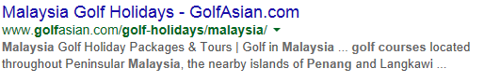
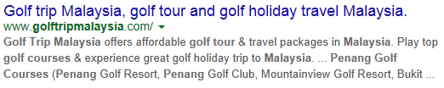
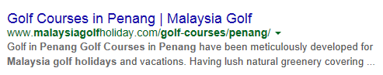

Conducting a further search
The Google search engine (and other engines also provide this option), enables you to use Search Tools to search within the results. You can select within the ‘Any time’ option to retrieve the most up to date information. This causes Google to run a new search using your newly specified query but only on the pages it found from your initial query, rather than over the entire web.
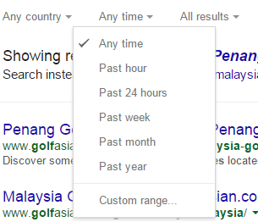

Too Many Results – You can focus the Search By …………… | Too Few Results – You can broaden the Search By …………
Adding a word or phrase | Removing a word or phrase
Specifying the order in which you want words to appear | Specifying words instead of phrases
Using a more specific term | Using more general terms
Identifying ineffective terms and removing them | Using a more common version of the word’s spelling
Limiting a date range | Removing a date range
Limiting where terms occur | Split up a multi-part query
Limiting the page to a particular country | Search the entire web

Advanced search function
As you also saw in Section 1, certain additional features and functions are available on all search engines, if you want more control over your searches.
If you don’t find what you’re looking for, consider specifying more precisely what you want by selecting an Advanced Search option. This function is easy to use and allows you to select or exclude pages with more precision than specifying search queries in the standard search box, as shown below.

Adding search engine functions to queries
Search engines also have functions you can add to a query to fine tune the results you receive. We’ll take Google as an example here and look at four additional query functions it offers:
- + Search
- OR Search
- Numrange Search
- Fill in the Blanks Search.

+ Search
Google ignores, but without effecting results, common words (where, the, how, etc.) or characters and letters (I, II etc.) that slow down your search. But the + Search function lets you use a common word, if it is essential in getting the results you want.
You can include it by putting a (+) sign in front of it. (Make sure you include a space before the (+) sign.)

For example, here’s how to search for entries about the Queen Elizabeth II cruise ship.

Queen Elizabeth +II SEARCH

OR Search
To find pages that include either of the two search items, add an uppercase ‘OR’ between the queries.
This is how you would search for a hotel in Phnom Penh or Siem Reap

Phnom Penh or Siem Reap SEARCH

Numrange Search
This function lets you search for results containing numbers in a given range. You can use Numrange to set ranges for everything from dates to weights.
Just add two dates separated by two full stops (periods), with no spaces, into the search box along with your search query words. Also specify a unit of measurement (in the Advanced Search window) of what the number range represents.
Here’s how you would make a query entry for tradeshows in Singapore from May to October 2016.

Trade shows Singapore May October 2016 SEARCH

Fill in the Blanks Search
You can ask a question in the search box and ask the search engine to answer it. You need to add an ‘*’ (asterisk) in the part of the sentence or question that you want filled in.
This shows how you would ask a question looking for information whether an International Drivers Licence can be used in Bangkok.

International Drivers Licence Bangkok * SEARCH

Activity12 – Determine most suitable search query results
NOTE: It is a requirement of this unit that you attempt this Training Activity.
Give two examples of queries using the +, or and numrange options.
Attach your answers to this activity and hand in to your trainer.
+

OR

Numrange

Find pages on surfing that are not about ‘surfing the World Wide Web’. Write down how you would phrase your search query.

Find a studio apartment to rent in Singapore and list the web address.

Fine tune the above query to a studio apartment located near the Singapore Botanical Gardens and list the web address.

Correctly selecting information
Having searched, in a number of ways, for a lot of information and gained a lot of results, how can you now go about selecting the information you most need to meet the customer’s original request for information from you?
Let’s go back to Google again.
The result that Google considers the most relevant is listed first. Consequently, you are very likely to find what you’re seeking quickly by looking at the results in the order in which they appear.
A search engine assesses relevance by considering over a hundred factors, including how many other pages link to the page, the positions of the search terms within the page, and how the search terms relate to one another. So, in other words, if you are using a method like a search engine, a lot of the hard work of sorting and selecting from the results is done for you!

Search result components
If you still need assistance in selecting just the right information you require, then again, the search engine can help you do this in a number of ways.
Below are descriptions of some search-result components. Some you are now familiar with. Working with these can help the selection process.
As you have seen, these components appear in fonts of different colours on the result page to make it easier to distinguish each from the other:
- Page title: The web page’s title, if the page has one or its web address. Click on the page title to display the corresponding page
- Extracts: Each search result usually includes one or more short extracts from the web page text that matches your query with your search terms in boldface type.

- Each extract is separated by an ellipsis (…). These extracts may provide you with:
- the information you are seeking
- what you might find on the linked page
- ideas of terms to use in your subsequent searches
- URL of result: Web address of the search result. (e.g. http//www….etc.)
- Note that large web pages are far less likely to be relevant to your query than smaller pages. For the sake of efficiency, a search engine searches only the first 101 kilobytes (approximately 17,000 words) of a web page and the first 120 kilobytes of a PDF file. This means that Google’s results won’t reference any part of a web page beyond these amounts
- Date: Sometimes the date on which the search engine sourced a web page appears just after the size of the page. The date tells you the freshness of the engine’s copy of the page. Dates are included for pages that have recently had an update
- Indented result: When the search engine finds multiple results from the same website, it lists the most relevant result first with the second most relevant page from that same site indented below it.
If you are clear on exactly what information you require, this will help you to conduct your search efficiently. Any time that you access a website, make use of the full range of information to you before looking elsewhere.

Available information
Once you become familiar with a website you will have some expectation of what information it contains on different products and services. It is worth taking the time to look at the websites of preferred suppliers so that when the time comes to access information, you know what you can find. Most companies will include a lot of detailed information on their sites as they would prefer you to stay within their site, rather than move out to look elsewhere. For example, sites that allow you to book discounted accommodation will give you the option to find out a lot of detail about the location, facilities, room types, etc. at each property.

Displaying information
When conducting a search for information and a list appears, there may be an option of displaying the list in a different order. For example, if searching for hotel availability in Singapore the list for Booking.com could be displayed:
- By star rating
- By price
- By location (distance)
- By deal.
Your client’s needs and requests will help you to determine the best way to display the information.
Look at the following screen shots from Booking.com website as an example. Note that the screen allows you to display the information in different ways. There is a ‘Sort’ bar at the top and a ‘Filter’ panel to the left hand side. The first example displays Singapore properties listed in order of price and the second screen is listed by star rating.
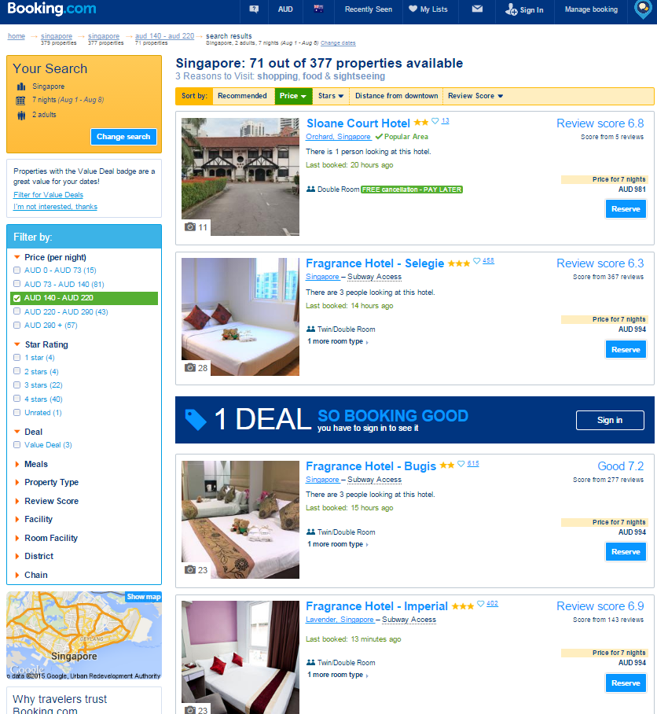
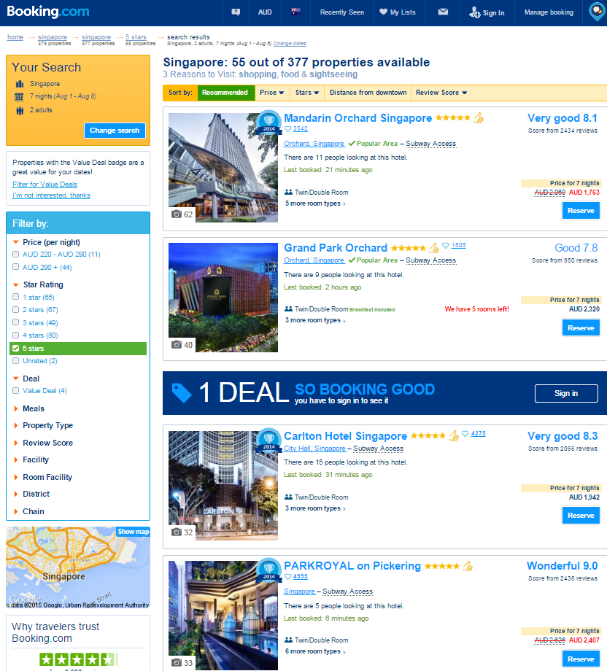

Navigating the website
Most websites have similar methods for moving around and accessing information. Below is some general information on navigation within the internet:
- If all of the information does not fit on one screen there will be a scroll bar down the side to help you move up and down
- If you are having trouble viewing an entire page, clicking the F11 function button on your keyboard will remove the toolbars and maximise your screen. To return to your normal view you just need to click F11 again to have the toolbars reappear
- A lot of websites have a ‘back’ or ‘return to previous screen’ button. If not then your general toolbar within Internet Explorer has a ‘Back’ button to allow you to return to the previous screen. This may not always work effectively. There is also a ‘Refresh’ button which allows you to refresh your screen
- You can access more than one website at a time and keep a number of different windows open. To do this you need to just open a new tab
- As mentioned earlier, most sites contain a search function to help you find information within the site
- In addition to a menu of information, websites contain hyperlinks that allow you to open a new page or box of information.
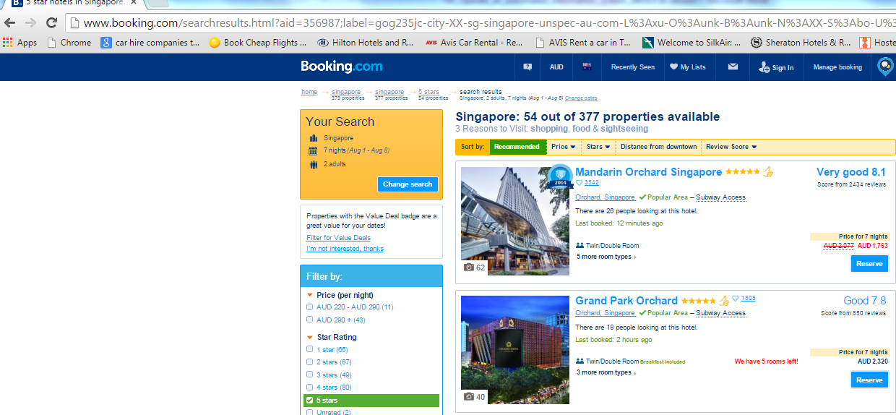
Refresh
button
Back
button

Hyperlinks
Words that are a hyperlink are generally indicated by appearing in a different font or a different colour. If you hover your mouse over the word then the mouse arrow becomes a small white hand with a pointed index finger. This indicates that you can click this word to find out more information.
This works the same for pictures and images. Sometimes while hovering you will also get a brief description. For example, hovering a mouse over a hotel picture may give you a prompt that by clicking on the picture you can access more photos.
Most websites will contain a number of hyperlinks so that they are able to provide a lot of relevant information but not clutter your screen.
Activity13 – Search information
NOTE: It is a requirement of this unit that you attempt this Training Activity.
- Imagine that you are working in a travel agency specialising in booking transport around South-east Asia. Make a list of ten websites you would include as ‘Favourites’. The list must include three airlines and three car hire companies, two coach companies and one train service.

- When searching for accommodation on a wholesaler website, list three different ways that the information could be filtered to narrow your search.

- Use a search engine to complete the following activity.
Scenario
You have a client tell you that they heard about a place in Indonesia where they can go whale watching but they don’t know the name of the place and neither do you! You use Google to help you. You type in the words ‘whale watching Indonesia’ which helps you to discover that Komodo is the name of the place.
Look at the client questions below, list three words you could put into Google to help you find information and then list the correct answer.
a) I heard you can do elephant trekking in SE Asia.
Three search words:
Answer:

b) I heard there is a great theme park in SE Asia for kids. Where is it?
Three search words:
Answer:

- Go to www.expedia.com
a) What is the minimum amount of information you need to input in order to get a price for a hotel?

b) There are a number of ways that you can make your information search more specific. List six hotel facilities that you are able to select to refine your search?

c) List four other products or services that can be booked for clients through Expedia.

2.5 Verify captured information meets identified need

Introduction
Once you have decided what information you need to provide to your customer, you need to ensure the scope and depth are appropriate.
The scope of information refers to the range of things they need to know. The depth means the amount of detail that they require. This means that when establishing your customer’s needs you have to not only work out what they want to know but how much information is required.

Ensuring accessed information meets purpose
Once you have entered a query and received a selection of results, you need to go through the results to find the most suitable result. But remember to note down any web sites that initially appear, so you can access them once you have completed all searches. You may also find you need to undertake further searches.
As well as refining your query and entering a few options if necessary, it is usual to search many results and then combine the most useful information in what you have received to answer the query you have entered.
For example, the ‘Golf Tours in Malaysia query may return you:
- Results of a few tour companies offering golf tours
- A specialised golf resort offering accommodation and a golf course, and, perhaps
- A guidebook on golf courses and touring around Malaysia.
You will then have to go through these results and sort them to find the most suitable selection for your query, and it may not necessarily be the first result you get that proves the most appropriate.
It is up to your discretion to decide how much information you need to provide. You need to consider your customer needs but also it will depend on what your job role is. For example, if you are working at a visitor information centre or an agency specialising in a particular product or destination, you may be required to provide a much greater depth of general information. If you are working in a travel agency selling worldwide destinations, the destination information you provide may be fairly general.
You need to be clear on your role within your organisation and if you are unsure, seek clarification. Although it might be great customer service to research everything that a client asks for, it may not always be practical or appropriate to do so. For example, a client may ask you to look up websites containing hotel reviews but your office may have a policy on not using these sites.

Activity 14 – Verify captured information meets identified need
NOTE: It is a requirement of this unit that you attempt this Training Activity.
Complete the example; Golf Tours in Malaysia:
- Mature age couple in their 50’s. On holiday for 6 nights. Require hotel accommodation in 4-5 star hotel. Would like to play 2 different golf courses but open to suggestion. Would like to meet or compete against others
- What information would you return to the couple to verify you are meeting their requirements?

Work Projects
It is a requirement of this Unit you complete Work Projects as advised by your Trainer. You must submit documentation, suitable evidence or other relevant proof of completion of the project to your Trainer by the agreed date.
2.1 Please complete the following activities relating to this Performance Criteria:
- Activities 6
2.2. Please complete the following activities relating to this Performance Criteria:
- Activities 3, 4
2.3. Please complete the following activities relating to this Performance Criteria:
- 7, 8, 9, 10
2.4. Please complete the following activities relating to this Performance Criteria:
- Activities 11, 12, 13
2.5 Please complete the following activities relating to this Performance Criteria:
- Activity14

Summary

Access information using an automated information system
Identify information requirements
- Qualifying what the customer wants
- Using sales skills.
Apply search techniques to locate identified information
- Selecting search methods
- Using key words and phrases
- Using system features
- Refining a query
- Decide social media platforms to be used.
Interrogate the system to secure full range of information available on the system
- Ensuring accessed information meets required scope and purpose
- Conducting a further search
- Advanced search function
- Adding search engine functions to queries
- Correctly selecting information
- Search result components
- Available information
- Displaying information
- Navigating the website
- Hyperlinks.
Verify captured information meets identified need
- Ensuring accessed information meets purpose.

Element 3:
Obtain information using an automated information system

3.1 Enable access to required system and/or information

Introduction
Within the tourism industry, your searches on line for information gathering may result in purchasing information or products being purchased.
For example, you might need to purchase an online travel guide or travel-related information via a tourism authority.
Or your purchasing might take the form of airline tickets—using an airline’s online reservation system, or even directly booking a hotel via an accommodation site directly and ensuring payment. This section looks at different types of purchases and security when accessing automated systems.

Information purchased for your organisation
Online information systems can be used for many purposes. Within your agency you may use these systems to purchase information for the agency to keep as a reference or give to clients. Examples of information you may purchase would include:
- Maps and posters
- Brochures
- Guide books
- Timetables
- Information pamphlets
- Baggage tags and ticket wallets.
Travel agents can order brochures and other printed materials through companies such as Brochure Flow. These companies allow agents to make one large order from a very wide variety of travel companies. Tour operators and wholesalers use a company called Brochure Flow to have their brochures delivered to agents as requested. Through the Brochure Flow site you can also access Electronic brochures for a variety of wholesalers and operators. This is extremely useful for travel agents as they do not need to contact every company individually.
Not all travel suppliers participate and sometimes you will need to directly contact a tour operator or supplier to request information. These companies will usually have a link on their website to make the request for information. You would need to enquire which company your organisation orders such material through.

Making purchases for your clients
The process of purchasing online varies depending on a number of factors including:
- The system you are using
- The product or service you are purchasing
- The availability of the product or service.
If you are making a flight booking through your Computer Reservation System, the rules of the airfare will determine when you need to take payment and order the ticket. If you need to use an airline website to make a booking then you will need to make the reservation and payment in the same transaction.
You need to make the client aware of the conditions of the fares you are quoting and ensure that you have all the necessary information required to make the booking.
Most suppliers and wholesalers have websites that allow agents to create quotes and bookings. Their terms and conditions will state when a deposit and the balance need to be paid. The payment deadlines can vary from one company to another, and also depend on the product being booked. Often tours and cruises will need to be paid in full 60 days prior to departure whereas many wholesalers will only require payment for accommodation 30 days prior. Stricter payment deadlines will apply when bookings are made for departures within 30 days.
Alternatively, you may make a booking on a website that requires immediate payment regardless of how far in advance you are making the reservation. Or you may make a hotel reservation directly through the hotel website and although a credit card number is required, the payment is only taken from the client at the time they check in. A similar procedure is used when making reservations directly through a car hire company.
It is your responsibility to make sure your client is aware of how and when payment needs to be made. You also need to be very clear when quoting a client if the products they wish to purchase are definitely available. For example, wholesaler websites may display hotel options that are ‘Available’ and also ‘On Request’. ‘On Request’ means that availability is not guaranteed. A booking needs to be requested and then the hotel is directly contacted by the wholesaler to check if there is a room available. This process can take 24-48 hours.
All of these factors will influence how and when you make purchases on behalf of your clients. A complex booking may involve the use of a number of different suppliers and wholesalers who all have different conditions. It is recommended to always type up a detailed quote or invoice for a client which clearly states all details of what has been booked and requested. This quote or invoice should clearly outline all the particulars of the booking including when and how payment needs to be made.

Security and automated purchasing
Automated or online purchasing is a security threat. But industry has developed technology that can scramble sensitive information, such as your organisation’s credit card number, so that it can be read only by the supplier you are dealing with and the credit card issuer. This ensures that payment information cannot be read by anyone else or changed along the way. There are several ways to determine if you have that protection when you are sending payment information on the web:
- Look for the picture of the unbroken key or closed lock in a corner of your browser window. Either one indicates that the security is ‘on’. A broken key or any open lock indicates it is not
- Look to see if the web address on the page that asks for your credit card information begins with ‘https:’ instead of ‘http’
- Some web sites use the words ‘Secure Sockets Layer (SSL)’ or a pop up box that says you are entering a secure area.
These security protections do not work in e-mail. So, make sure you send an individual’s personal details and payment information only in a secure web transaction.

Points to remember when purchasing online
- Double check pricing. Be suspicious of prices that are ‘too good to be true’, and always compare pricing
- Find and read the privacy policy. Read the privacy policy carefully to find out what information the seller is gathering from you, how the information will be used, and how you can stop the process. If a site does not have a privacy policy posted, you may not want to do business there. If it does have a privacy policy, there will probably be a link to it from the seller’s home page, or it could be included with the Legal Terms
- Review the return, refund, and shipping and handling policies as well as the other legal terms. If you can’t find them, ask the seller through an e-mail or telephone call to indicate where they are on the site or to provide them to you in writing
- Print the terms. You should print out and date a copy of terms, conditions, warranties, item description, company information, even confirming e-mails, and save them with any records of your purchase
- Make sure the internet connection is secure. Before you give payment information, check for indicators that security software is in place
- Use the safest on-line payment method. Your organisation is likely to have a policy regarding this. For example, pay for your order using your organisation’s credit card.

Type of information sites

Bookmarking sites
Bookmarking sites allow users to save and organize links to any number of online resources and websites. A great feature of these services is the ability for the user to “tag” links, which makes them easier to search and share with their intended audience and followers. StumbleUpon is a popular example of a bookmarking site.
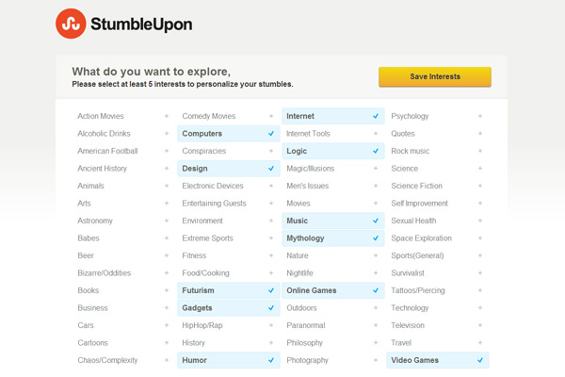

Social news
Social news sites allow companies and individual users to post news links and other items of interest or importance to outside articles. Users then vote on specific items with the items with the highest number of votes are most prominently displayed. A good example of a social news site is Reddit.


Media sharing
Media sharing websites allow users to share different types of media. This commonly includes video and pictures. Many of these sites offer social features, enabling profiles to be created and allowing people to comment on the uploaded images. YouTube is the most well-known media sharing site in the world.
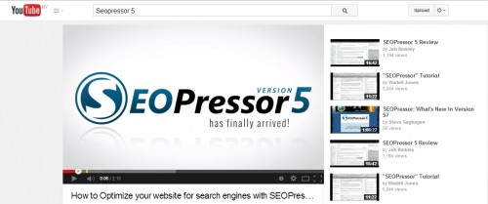

Microblogging
These sites allow the users to submit short written comments, which can include links to:
- Product and service sites
- Other social media sites.
These are then posted on the ‘walls’ of everyone who has subscribed to that user’s account. The most commonly used microblogging website is Twitter.
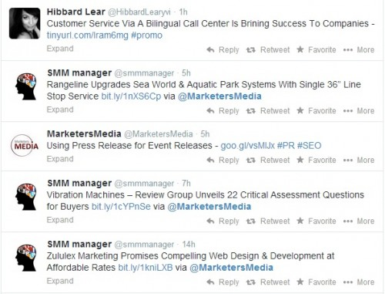

Blog comments and forums
An online forum is a site that facilitates users to engage in conversations by posting and responding to community messages. A blog comment site is the same thing except a little more focused. The comments are usually centred on the specific subject of the attached blog. Whilst Google has a popular blogging site called ‘Blogger’ there are many niche-based blogging sites aimed at specific topics and audiences.
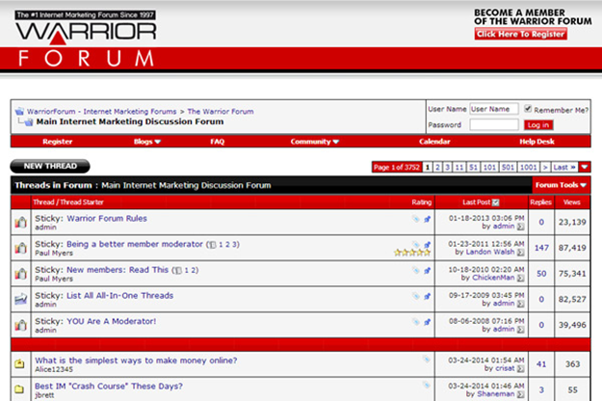
Activity 15 – Information sites
NOTE: It is a requirement of this unit that you attempt this Training Activity.
Using a different source each time copy a sample of tourism based information that you may use for clients from each of the following sites:
- Social news
- Bookmarking sites
- Media sharing
- Microblogging
- Blog comments and forums.

3.2 Select required information

Introduction
Once you have determined what information you need to access for your client, you will need to make a decision on where to start looking. Sometimes there may be only one logical choice on the best place to look - for example, using your Computer Reservation System to look for flights. Other times, there may be a range of options and you may not be sure where to start.
Whether you are looking for general information or specific details from wholesalers and tour operators, you need to consider the reliability and reputation of the information source.

Preferred suppliers
Earlier in this topic ‘preferred’ suppliers have been mentioned. These are suppliers with whom your organisation has an established relationship and you can confidently access information and sell products from these companies. You will most likely have their brochures displayed in your store and if your organisation has an intranet site, it may have a link to preferred supplier websites. This is a great place to start looking for information.
If you are trying to find general travel information it is not a good idea to just do a general search through a search engine such as Google unless absolutely necessary. Firstly consider any other sites that have been recommended to you that you are confident will have reliable and up to date information. The problem in searching generally and not knowing your information source is that you cannot be sure that the information is current and accurate. For example, information on local transport, activities etc. may no longer be current or hotel information and ratings may only be based on someone’s personal opinion.
Experience will help you to make decisions on where to start your search. When you are starting out in the travel industry you need to take the time to look at your available resources, particularly brochures and preferred supplier websites. It is also a good idea to get an idea of the clientele you may be dealing with frequently so you can anticipate what their information needs may be and perhaps prepare a list of useful resources to use in the future.

Best option data
When looking for accommodation, tours, and so on you may find that there is more than one preferred supplier who will have the information you require. If you are trying to find the best price for your client, it may mean that you need to check more than one source of information so that you can confidently give your client the best price you can. Again, familiarity with how to access and search through frequently used online information systems will make this a much simpler and time efficient task.
You may like to review1.1 Identify a range of information systems and sources within the industry and 2.4 Interrogate the system to secure full range of information available on the system.to again consider the sources for potential information and methods for interrogating those sources to obtain the best information for your client.

Activity16 – Select information
NOTE: It is a requirement of this unit that you attempt this Training Activity.
A family holidaying in the local region enters your visitor information centre. They have arrived by car earlier in the day and at this stage have not chosen any accommodation in which to stay. They request information from you about the major attractions of the town and immediate surrounding area and indicate that they are particularly interested in outdoor activities which may be suitable for their young children. In a couple of days they will travel north, and would also like information on the area into which they are travelling. Access and print information for this family regarding:
- Suitable accommodation options
- Major attractions
- Outdoor activities.

3.3 Download information

3.4 Print information

Introduction
When sourcing and providing information, remember that quality is more important than quantity. You need to ensure that you have met all of your client’s information requirements but also make sure that you don’t overwhelm them with irrelevant information. This section looks at the downloading and printing of data and information.

Downloading information
To ‘download a file’ means to copy a file from another computer on the internet to your own computer.
When you go to a web page you are downloading the information required to display the web page on your computer.
After selecting relevant information you need to determine if it is to be purchased (in the case of bookings) or simply downloaded .In many cases a copy of any purchase is required to be saved for reference. Company policy will dictate if you are to download that information and print it out, or print directly from the source.
Downloaded information is most likely to be in the form of a saved Web page, a PDF file, a Word file, a PowerPoint file or an Excel Spreadsheet file. The formats that may place the computer you are working on at most risk are Word, PowerPoint and Excel files, as these can carry viruses more readily than Web pages and PDF files.

Size of file and length of download
When downloading, you should always check the size of the files and estimate the time required to download them. The larger the file, the longer the time it will take to download. Will the Internet connection you have access to mean downloading larger files will be slow, or relatively fast? Does your enterprise have broadband or wireless access (relatively fast downloading) or dial up access (relatively slow downloading)?
When downloading information from the internet there are some things you should keep in mind about the time it will take you to download it, how to save it, and the copyright ownership of the material.
Here is a further brief listing of some Do’s and Don’ts on downloading information, including say, a supplier’s software, from the Internet:
- Do make sure that you read any downloading instructions
- Do backup your system just in case something goes wrong
- Do make sure that you scan the file for viruses before opening it even if it is from a trusted source. Typically, you can do this in a Windows format by right-clicking the file and selecting ‘scan’ from the pop up menu
- Don’t download information or software through a file sharing program. You have no idea what you may or may not be getting
- Don’t download information or software through e-mails, unless it is from a trusted source
- Don’t download from unreliable sources.

Downloading information
After downloading information you may also need to print the information to give to the client or to keep in their file. You need to make the decision on whether or not the information is worth printing and if you do need to print, how to present this information to the client.
Make sure you are familiar with the information before sending it to clients. If you have a few pages, ensure you highlight to them the most relevant points of information. Don’t just print numerous pages, or cut and paste pieces of information together. This will confuse the client and doesn’t look professional. You want to be sure that your client sees you are confidently presenting information to them and in a professional manner.
You may need to seek information from your manager on how to present information to the client. It may not be acceptable in your organisation to just print screens of information and to give these to a client. Similarly, some agencies will have a policy that they will happily forward a web address or link to a client while other companies have strict policies to not do this.
Some travel agencies will also have procedures relating to the presentation of itineraries to clients. Some will print itineraries straight from the Computer Reservation System or airline website while others will only give out itineraries generated through their Client Relationship Management System such as:
Crosscheck™ by Travelport ™ which interfaces with Galileo™
https://support.travelport.com/NR/rdonlyres/8A70D084-2C4E-41F3-AAC0-0956F321214E/0/CCT31_CM.pdf
or ISO Travel Solutions™
http://www.isogmbh.com/services/travelsoftware/tour-operator/crm-for-tourism.html?gclid=COqL3tPIrMYCFVMIvAode5sGvg
Some information you will need to download from wholesaler and tour operator sites is intended specifically for the travel agent and is not to be shown to the client. This includes quotes, invoices and any information relating to agent commission. This is generally stored in a client file, either printed in a paper file, or stored electronically.

Printing information
When printing from your automated system, it is critical to follow the company procedure of your employer. Many enterprises will have standard written, or at least verbal, directions on what is acceptable to purchase or print for your organisation and customers.
Previewing a document is a good way to view the document on screen and see how it will look when printed. Use the print preview function to check the layout and design before printing.
Each office program print preview display will differ slightly but the functions will be the same. Changes can be made to the margins from here, the size of the preview can be adjusted and readability is clear for proofreading. Scroll through the document to view the layout and design.
Click close and return to the main document.
Once you have made any corrections to the document you will need to print a hard copy.
Check the printer is on and working. If the printer is off line it cannot print. Ensure the correct paper is loaded and if you are using letterhead ensure it loaded the correct way (this may be face-up or face-down) so the information prints on the correct side.
If you are printing multiple copies it is a good idea to print one first to check everything is as it should be.
Example of a print screen
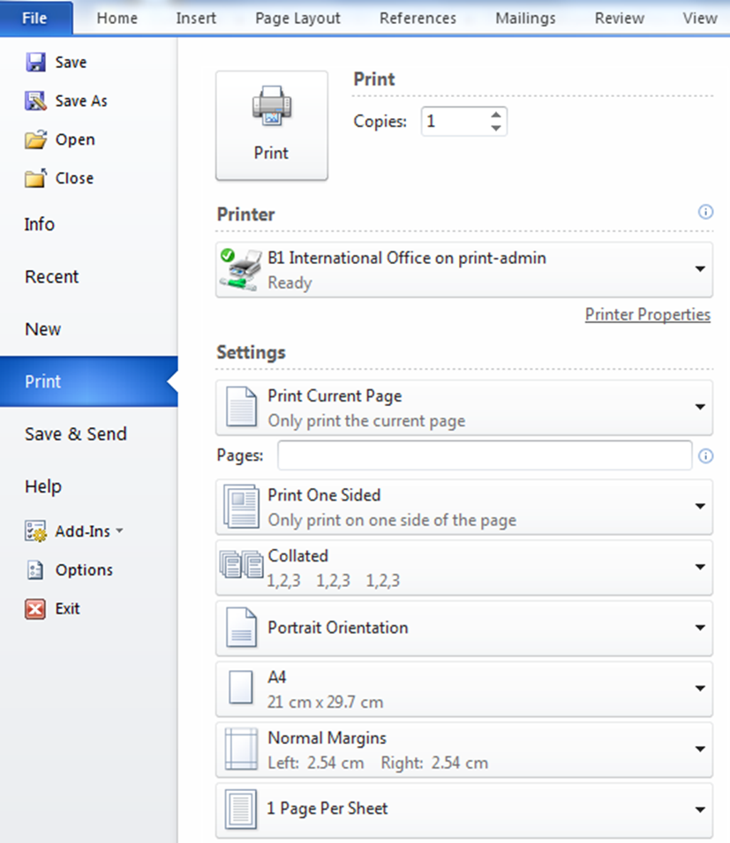
- You will need to ensure you have selected the correct printer if there is more than one
- Do you require a black and white or colour copy. Many companies limit access to colour copiers as they are costly to operate. It is wise to print a black and white version for proofing before printing colour versions
- You may need to select which page numbers you wish to print. This is a vital step if you only require a few pages from a large document.
- Most printers default to portrait printing so if you wish for a landscape printout you will need to select that preference within print orientation
- You will also need to select if you wish to print single sided or double sided copies.
Printer properties is a linked page and will take you to a page that looks something like the one below depending on which program you are using. There a multiple tabs and print options within this screen which allow more complicated print jobs.
Take time to discover how your printer operates and ask for some training or you risk wasting a lot of time and paper!
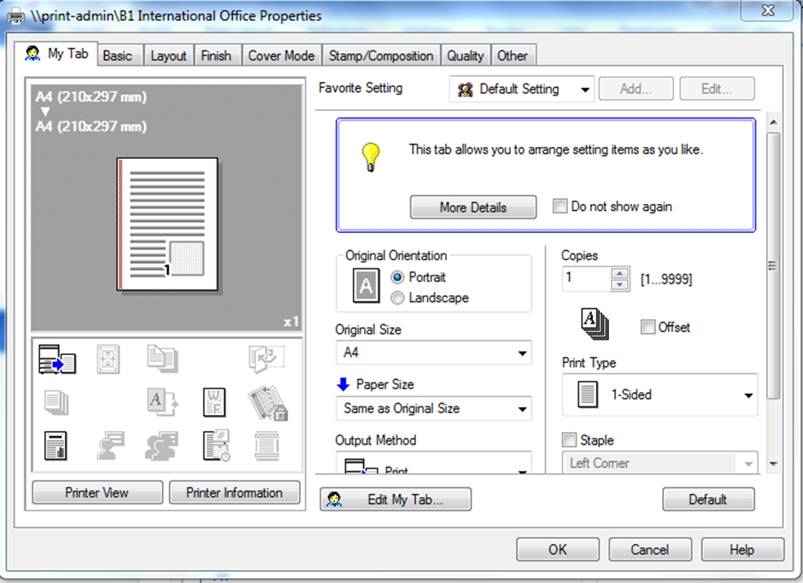

Activity 17 – Download and print information
NOTE: It is a requirement of this unit that you attempt this Training Activity.
Scenario
You have booked your clients on an Air Asia flight from Bali to Cebu. They have requested some additional information from you.
Use the Air Asia website to answer their questions and to find the information they require.
- What is the name of the Air Asia frequent flyer program?

- Is there a cost to join this program?

- Access the application form. Either print the application form and attach it to this page or write down the web address to access this page.

- Search ‘Cebu city guide’. Identify two sites you would source information from and indicate how reliable you think the information is.

- List two other ways of presenting this information to your client.

Work Projects
It is a requirement of this Unit you complete Work Projects as advised by your Trainer. You must submit documentation, suitable evidence or other relevant proof of completion of the project to your Trainer by the agreed date.
3.1 Please complete the following activities relating to this Performance Criteria:
- Activities 15
3.2. Please complete the following activities relating to this Performance Criteria:
- Activities 16
3.3. Please complete the following activities relating to this Performance Criteria:
- Activities 17
3.4. Please complete the following activities relating to this Performance Criteria:
- Activities 17

Summary

Obtain information using an automated information system
Enable access to required system and/or information
- Information purchased for your organisation
- Making purchases for your clients
- Security and automated purchasing
- Points to remember when purchasing online
- Bookmarking sites
- Social news
- Media sharing
- Microblogging
- Blog comments and forums.
Select required information
- Preferred suppliers
- Best option data.
Download information / Print information
- Downloading information
- Size of file and length of download
- Printing information.

Element 4:
Use information from an automated information system

4.1 Forward information as required

Introduction
After you have accessed information, either for a specific client request or for yourself to use as a reference, you need to decide what you will do with it. There are factors that will influence your decision regarding how to organise and present the information to your client.

Forwarding information by email
There may be times where you decide to send information to your client via email. You may wish to attach a relevant document or send them a link to a relevant website. Similar to when handing your client printed information, you need to ensure they understand why you are emailing this information to them. Make sure your email includes a clear explanation of why you are forwarding the information and what you would like them to be aware of.
If you are forwarding information to several people, think about using the blind carbon copy (Bcc) function so that a long list of recipients does not appear on everyone’s screen and email privacy can be maintained.

Verbally sharing information
When giving information to your client it is important to explain to them how the information meets their needs. This is particularly important if you have had to select an appropriate product that you are suggesting or recommending. Generally it is not recommended to just verbally share information with your client and not record it in some way. Keep notes of the information you are giving to clients so that it can be easily retrieved in the future.

Information regarding prices
Many travel companies will have a policy that any pricing quoted to clients should be given to them in writing, as one typed quote for all of their travel arrangements. Although it might be appropriate to show pricing in a brochure to a client during an initial enquiry, if you are putting together a quote for specific travel dates, and particularly if it includes more than one product, a quote should be prepared on your company letterhead.

Activity18 – Forward information
You have been researching information on children’s activities in Singapore for a couple with three children aged 8, 12 and 14 who will be travelling in January.
Provide a copy of your research and detail how you will forward this information to the family and check its suitability.

4.2 Save identified information

Introduction
You can spend a good deal of time searching for information to meet client requests. Once you have found what you are looking for or have finished creating a document you need to save it so you can easily locate it again in the future.
If you are saving information from the internet be sure it complies with your companies policies. If you intend on reproducing the information remember to take into account Intellectual property and Copyright considerations.

Saving files
The information files you download are most likely to be in PDF format, although some may be Word or Excel.
Saving PDF files to your working computer is as easy as clicking on ‘Save’ or the ‘Disc’ icon in the menu bar and typing into the relevant pop up window the name of folder on your computer you want to save the file in.

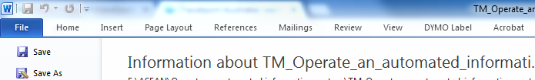
You can cut and paste material from PDF files into a Word file of your own, unless the PDF file has been deliberately locked to prevent this.
Saving Word files from the Internet is as easy as saving PDF files, but remember to run them through you virus scan before downloading.
You can also save a Web page, unless it also has been locked. Again it is possible to cut and paste text from a web page into a Word file to organise relevant information for a customer (an issue we will look at soon).

Downloading and saving software
To read PDF files you will need PDF file reader software such as that provided (free) by Acrobat. If you don’t have this software on your working computer, it will prompt you to find it and download it.
When you have found the right software and you are ready to download, the site you are visiting will more than likely have a download link which you can click on to start the software download process.

After you click on the software download link, a box will pop up and you will be given the option to Run, Save or Cancel the download (asssuming you are working with a Windows system). It is very important that you choose the Save option so that you can save it to your computer in the place that you want, and so that you can run it at a later time if you wish to. If you choose run, it will download the file to a temporary folder and automatically start the installation.
When you click on Save, you will be prompted to save it in a specific directory on your computer hard drive. You should download it into a directory on your hard drive so that after you download the software it will be easier for you to find. Or, you can simply download the file directly to your desktop. This way, you know exactly where the file is and it can save you time spent in trying to hunt down the software on your computer.
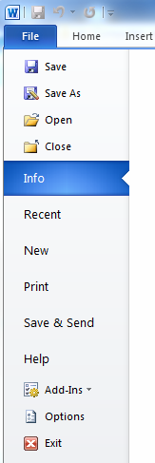
Once you have finished installing, and depending on the software, you can choose to have a desktop icon created so that you can simply click on that to start the program. The desktop icon will allow you to quickly start the program and save you from having to find it on the Start menu.
The best place to start with your newly downloaded software is the Help file. The Help file will take you through the steps of using the software, and many Help files often have a Quick Start Guide included, so that you don’t waste all your time reading and can start using the software immediately.

Saving files in Word

STEP One: Saving a file the first time
Locate the “File” option on the toolbar (top left of the menus)
- Single left click on “File”
A new window appears, with other options:
- Hover cursor over “Save”
- Single left click on “Save”
A window appears labelled “Save As”:
- You need to decide where you will save your file
- Towards the top left of the box, there is a white rectangular box that has “save in” to the left of it
- On the right hand end of the white rectangle is a small arrow pointing down. This is a drop down arrow and indicates that there are options hidden
- Single left click on the arrow.

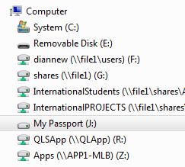
A number of options will appear, including:
- My Computer
- C:
- My Documents.
If you have loaded your memory card/USB card into the computer prior to this step, it should appear as something like….E:/removable memory device.
To save your file in this area:
- Hover your cursor over the option you want
- Single left click
- Select your removable memory device.
At the bottom of the window, there is another white rectangle with “File name” written next to it:
- Hover your cursor over the title already showing, select the text (Left click and hold down on button, drag cursor across all text. Should be highlighted blue)
- Press delete once
- Enter your filename
- ENTER.

Step TWO: Saving after that…..easier!
Now that you have saved your file the first time, you have created a “pathway” and whenever you have the file open in Word, it remembers that pathway. To save the file in progress, while you are working on it, simply locate the icon on the toolbar that looks like a small computer disk (top left, usually located beneath edit &view) and single left click on the icon. This will save the file again over the original file in the same pathway:

- Hover your cursor over the icon (a small label will appear telling you what the icon is)
- Single left click.

Step Three: AutoSaving
Word has an “Autosave” option, meaning that every so often, usually ten minutes or so, the program automatically saves the current file. However, don’t trust this option, it is far safer to simply click the save icon yourself every now and again and be sure you have saved your valuable work.
To follow up more detailed information in this section, you could try Google Guide at:
<www.googleguide.com>.

Saving to the appropriate location
It is important to maintain an organised electronic filing system. Documents and folders must be named, coded and filed according to a logical classification often determined by company policy. Generally the folder name clearly identifies the contents. For example Ocean Cruises 2015 or Cooking Tours 5-10 days_2015.
To ensure an efficient filing system you will need to:
- Label documents in an easily recognisable and logical manner
- File documents to folders
- Always back up your files. In other words don’t just save them to the desktop as computer breakdown, virus attack or accidental deletion can cause you to lose all of your information stored in this area. Save to the hard drive regularly or before closing down your computer at the end of your shift.

Copyright and intellectual property
Note that there are some do’s and don’ts relating to who holds the copyright and intellectual property (IP) in any material you download and/or cut and paste from the internet.
Unless the website or PDF file clearly states otherwise, you should presume that the website owner is also the owner of the IP and the copyright on that material. Most websites have a statement such as ‘© ABC Travel 2007’ at the bottom of a home web page and a further statement about how their material can or can’t be used.
Don’t, for example, cut and paste some information from, for example, ABC Travel’s website, word for word into your enterprise’s new brochure on, for example, Pacific Cruises, and then print it and distribute it to potential customers. You must first ask ABC Travel’s permission to use their material. And if they say ‘no’, you cannot use that material at all. You could rewrite the information in that material in your own words, but you should still acknowledge ABC Travel as the original source for the information you rewrite.

Activity 19 – Downloading information
NOTE: It is a requirement of this unit that you attempt this Training Activity.
Download from an automated information system, and print out, a list of conferences being held in Singapore in September 2016. Attach your list to this Learner Guide for assessment.

4.3 Manipulate accessed information

Introduction
With the business environment becoming more and more competitive, all customers expect to be recognised as individuals and receive some element of personalised service.
Whilst this is not always possible, each organisation should try to identify, record and use personal information regarding the likes and preferences of customers where possible.
With greater use of technology, we have the ability to record information, so that it can be used to provide greater personalised service is possible.

Customer databases
One way of compiling information on each customer is through the use of databases.
Customer databases are being incorporated into more and more business-related software packages, or offered as a stand-alone management and customer service tool. They may be referred to as PMS (Property Management Systems).
They can be used to record a wide range of customer information that can be used to personalise service delivery and hence provide quality customer service.
When might information be captured and recorded?
Customer information and details may need to be recorded when customers:
- Register as a customer
- Register for a loyalty scheme
- Lodge a request for further information about a product/service
- Seek a quote
- Request to be added to an internal database
- Return a product for some reason
- Make a complaint.
Information to capture
Many systems create a default database of past customers by archiving customers into a Guest History that may contain information such as:
- Contact details – or a pathway to these details
- Dates of the travel
- Special requests made
- Complaints raised and action taken to resolve those complaints
- Transactions records
- Details of items bought or returned
- Value of the customer – in dollar terms
- Sales data – including preferences
- Indication of the status of the customer – such as whether they belonged to one of a nominated range of classifications
- Customer reward schemes
- Anniversaries or special dates.
Some systems will flag the screen or automatically populate certain information fields when a booking is made for a customer whose details already exist within the system.

Using Microsoft® Excel as a Database

Organising Data
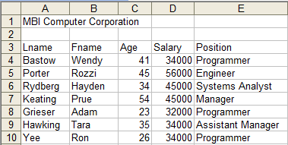
Microsoft Excel allows data to be stored in a list. A list is a collection of organised data stored in rows with labelled columns. You can think of a list as a database, where rows are records and columns are fields.|
A field is a single column
Column labels are field names
D
a
t
a
B
a
s
e

A record is a single row in the list

Microsoft Excel automatically recognises a list as a database when it is requested to perform database functions such as finding, sorting or subtotalling data.
Microsoft Excel databases grow downwards; therefore you should always ensure that you have blank rows below the database to permit easy addition of new records.
To start this exercise open up Excel and create the MBI Computer Corporation database shown above. This database contains a typical database structure consisting of a list of employee names, ages and job positions.
The database containing employee information for MBI Computer Corporation is stored in the cell range A3:E10. To activate Microsoft Excel's database functions you must make a cell within the database range active. Place your cursor over A3 and click to select the cell making this cell active.
Using a data form.
To examine, edit and move through the records of a database, Microsoft Excel provides a special dialog box called a data form. A data form displays one record at a time. When a data form is opened, Microsoft Excel displays the first record in the database.
Microsoft Excel is able to find the first record in the database automatically as long as you have column labels across the top row of the database and the active cell is inside the database range.
To open a data form:
Click A3 to select it.
Choose the Data menu, then the Form command.
Remember if the Form command is not visible, you may have to click .., to display all the commands under this menu.
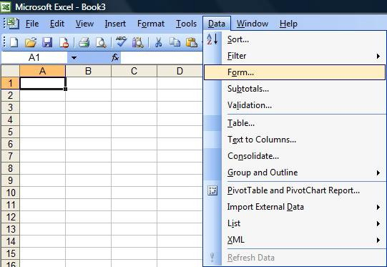

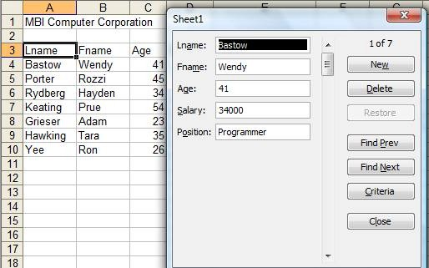
A data form appears displaying the first record in the database.
Record Number Indicator
A data form can display up to 32 fields.
The record number indicator is displayed in the upper right-hand corner of the data form. This indicates which record is being displayed and how many records are in the database.
The command buttons on the right side of the data form may be used to:
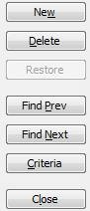
add a new record to the database
delete a displayed record from the database
undo changes to the displayed record
move to the previous records
close the form and return to the worksheet
find records based on criteria you specify
move to the next record

Using a data form to edit records
You may change the details of any displayed record by simply editing the data spreadsheet inside the field boxes in the data form.
To change the Age field of the displayed record from 41 to 42:

Double inside the Age field edit box:

Click worksheet
Type 42 to alter the Age
Using a data form to add records
You may add records to the database by clicking the button
in the data form.

Type the new record details pressing the <TAB> key to jump to each field box and the NEW button to enter the next record or the CLOSE button when all data has been completed.
You will now use the data form to add the following records to the database:
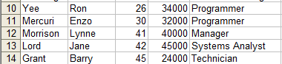

Using a data form to find records
You may use the data from feature to find and display records that meet particular criteria. For example, you might want to access records of employees aged 30 years or older. Or you might want to access records of employees who are Programmers.
Follow the instructions below to set up a search criteria that will find records where the Age: field contains 30 or higher, and the Position: field contains the word Programmer. In other words, you wish to access records of employees who are 30 years of age or older and are classified as Technicians. To make the search easier, you need to move to the first records.
Click on the Criteria button in the data form.
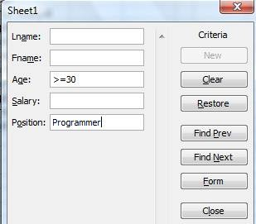
Type >=30 in the Age: box


Type Programmer in the Position: box
Click the

button to activate the search.

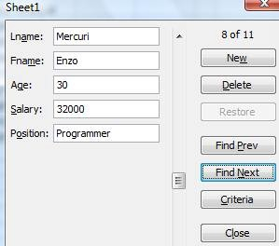
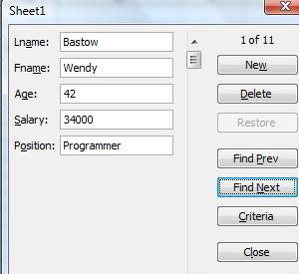
Click

to continue searching
The following data form is displayed:

Click the Close button to exit the data form

Sorting on one field
You will find that it is easier to work with data in a database when it is sorted in some order based on the contents of one or more fields.
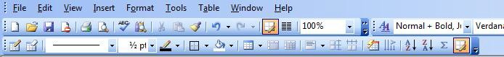
There are two buttons on the Standard Toolbar that allow you to sort in either ascending.
order
or descending order

If you wish to base a sort on a single field (column), using the sort button on the Standard Toolbar provides the quickest method.
To sort the database into last name alphabetical order:
Click on any cell containing a last name in Column A - for example, cell A12.
This action nominates the sort key to be the field storing employees' last names.
Click the Sort ascending
alphabetical last name order.

button on the Standard Toolbar to sort the database

Sorting on multiple fields
Microsoft Excel allows you to sort on more than one field. For example, suppose you wish to sort the database in Position order first, then Last Name order for records having the same Position. In this example, two sort keys would have to be nominated. Microsoft Excel allows you to nominate up to three sort keys for operation.
To sort the database using two sort keys, use the Sort command from the Data menu.
Before activating a multiple field sort, make sure the active cell is inside the database cell range.
Choose the Data menu, then the Sort command to display the Sort dialog box.

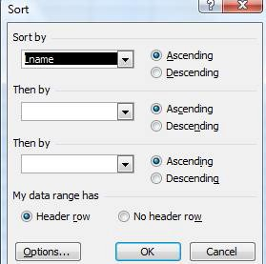

Notice that Excel highlights your database automatically.
In this exercise you will set two sort keys - Sort by Position, Then by Lname.
Click the down arrow of the Sort By drop-down box to display the field names in the database.
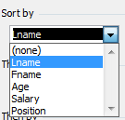
Click Position to select this field as the main sort key.
Click the down arrow of the first Then by drop-down box to display the field names in the database.
Click Lname to select this field as the second sort key.

The Sort dialog box now appears:
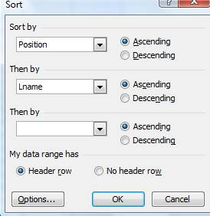
Click OK to perform the multiple filed sort.
After the sort is completed the worksheet should appear as:
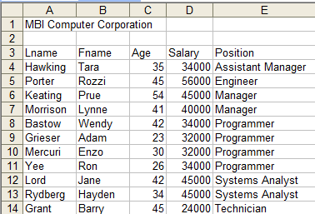
Notice that within each group of Positions, the records have been sorted in alphabetical.
Last Name order.

Automatic subtotals
Microsoft Excel's automatic subtotal feature provides a useful total for summarising data within a database. Before applying automatic subtotals the database must be sorted on the field you want subtotals calculated.
The database you have been working with is currently sorted on the Position field. To apply automatic subtotals to this database you must name the Position field as the control field. Microsoft Excel will then produce a subtotal for a nominated column every time the contents of the control field changes. For example:
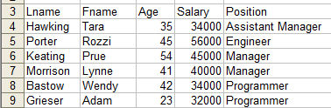
Automatic Total would be placed here
Automatic Total would be placed here

The subtotal calculation is selected from a range of functions, some of which include:
- Sum – adds a column
- Count – counts the number of items in a column
- Average – calculates the average of numbers in a column
- Max – identifies the maximum value in a column
- Min identifies the minimum value in a column.
Follow the instructions below to produce subtotals on the Salary column, for each Position field grouping.
Before setting up subtotals, make sure the active cell is inside the database cell range.
Choose the Data menu, then the Subtotals command to display the Subtotal dialog box.
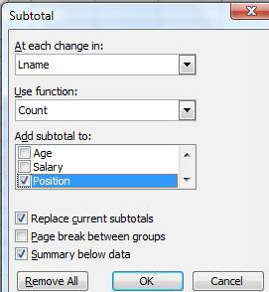

Alter the Subtotal dialog box to match the settings below:
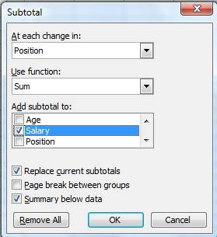
The settings above will produce subtotals on the Salary column, for each Position field grouping.
Click OK to subtotal the database records.
After the subtotals are calculated the worksheet should appear as:
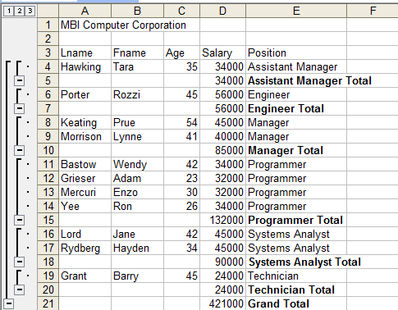
When Microsoft Excel adds the subtotal rows, it displays the worksheet in Outline mode.
This provides special buttons to hide details rows and only display total rows.
The Outline mode inserts three numbered buttons in the top left-hand corner of the worksheet.

Display Grand Total Display all Rows
Hide Detail Rows to display Totals only
Click 2 to hide detail rows and display Totals only.
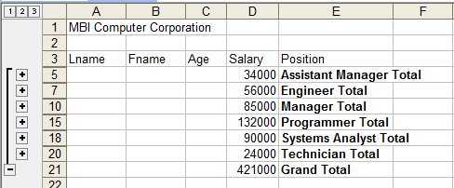

Click 1 to display only the Grand Total
Click 3 to display all rows
To display all the data (remove the subtotals):
Click A5 to select a cell in the data range
Choose the Data menu then the Subtotals command to display the Subtotal dialog box
Click to display the data (removes the subtotals)

Saving your work
Before finishing these exercises you should save your work.
Choose the File menu, then the Save or Save as command to save your workbook to a USB.
Reference:
Hawkings, P., McCarthy, B., Nikakis, C. (2004), The 2003 Stable: an introduction to Microsoft® Office 2003, Microsoft® Excel 2003, Chapter 7: Organising Data, pages 259 - 273, Pearson Education Australia, Frenchs Forest, NSW.

Activity 20 – Manipulating information
NOTE: It is a requirement of this unit that you attempt this Training Activity.
Create a database using Excel, with the following 15 column headings:
- Title
- Given Name
- Last Name
- Position
- Company
- Address1
- Address2
- Suburb/City
- State
- Country
- Postcode
- Phone Bus
- Phone Mobile
- Email
- Work Address
Input Data
Save to your USB as Singapore 2016 delegate list.
Adjust the column width so that all data is displayed in the cells, change the page set-up to Landscape and Print a copy to submit.

Create a simple database query
Create a copy of the above file and save it using a different name e.g. delegate list 2.
Condense the database by keeping only the following 6 column headings and data:
- Title, Given Name, Last Name, Position, Company, Email.
Add in 2 more column headings titled Registration type, Value: and input the data from the attached sheet.

Run a query that sorts the data by Registration type, then Organisation, then Last name. Print this document.
Title | Given Name | Last Name | Registration Type | Value
Mr | George | Tran | Early Bird | $275.00
Dr | Christopher | Short | Full Registration | $300.00
Ms | Julia | Marriott | Early Bird | $275.00
Dr | Michelle | Jenkins | Tuesday Day | $143.00
Mrs | Julie | Mitchell | Full Registration | $300.00
Ms | Emma | Brown | Early Bird | $275.00
Dr | Patrick | Chan | Full Registration | $300.00
Dr | Tony | Wong | Full Registration | $300.00
Ms | Rosalie | Nguyen | Tuesday Day | $143.00

4.4 Report on findings

Introduction
When conducting research you will always need to report back to your client to confirm that the material you have sourced is appropriate and on track for what they have requested. In addition to reporting to clients there will also be times when you need to report improvements, ideas and suggestions to colleagues or management.

Making recommendations
You might have been asked to develop a possible solution to an existing problem. For example, you might be required to recommend a more efficient system for work procedures and reduce costs, or to find ways of increasing client interest in the company’s products and services. Your research report would therefore probably contain a description of the present system and the problems involved with that, followed by ideas for ways to change the situation.
The report would generate recommendations and specific suggestions on how the organisation can go about changing the situation. The audience might be senior executives of your organisation or the staff in your department. It is likely they will have input into such a report by providing detail on current practises.
Your document might ultimately be used by others to make decisions therefore the information and recommendations (if any) that you present should be sound and clear.
If there is more than one recommendation, consider the order in which you present them. They might, for example, be in order of cost and feasibility (the easiest and cheapest option first), or in order of need (the most urgent option first).
Activity 21 – Report to clients
NOTE: It is a requirement of this unit that you attempt this Training Activity.
You have a group of ten people who are attending the Green Energy Asia exhibition in Kuala Lumpor in June 2016. They will be travelling to the city and staying 5 nights. You are requested to put together a calendar of events to entertain the group whilst they are there. They enjoy dining out, playing golf, some wish to see a few sights. They are all in their forties and fifties. They don’t wish to be extravagant but reasonable pricing will not be an issue. Four star accommodation is preferred. They are travelling from Jakarta.
Report back to the group via email on your findings.

Work Projects
It is a requirement of this Unit you complete Work Projects as advised by your Trainer. You must submit documentation, suitable evidence or other relevant proof of completion of the project to your Trainer by the agreed date.
4.1 Please complete the following activities relating to this Performance Criteria:
- Activity 18
4.2. Please complete the following activities relating to this Performance Criteria:
- Activity 19
4.3. Please complete the following activities relating to this Performance Criteria:
- Activity 20
4.4. Please complete the following activities relating to this Performance Criteria:
- Activity 21

Summary

Use information from information an automated information system
Forward information as required
- Forwarding information by email
- Verbally sharing information
- Information regarding prices.
Save identified information
- Saving files
- Downloading and saving software
- Saving to the appropriate location
- Copyright and intellectual property.
Manipulate accessed information
- Customer databases
- Organising Data.
Report on findings
- Making recommendations.

Element 5:
Up-date and maintain information on an automated information system

5.1 Enter data onto automated information system

Introduction
You will be required to open, generate and amend data, according to task and organisational requirements. It is beneficial to reinforce certain basic computer principles and list essentials expected by employers.
It is accepted that individuals may be perfectly competent with one software package, yet totally unfamiliar and incompetent with another; you should accept that a current inability to fully utilise an existing workplace system is not indicative of overall computer adequacy.

Update and maintain information
Operators must be able to perform the following word processing tasks:

Retrieve, view and close a word document;
Select and access the necessary word processing application on your computer:
- Locate and open a nominated word processing document
- Scroll through the document to view required information
- Close the document
- Close.

Create, save and print a word processing document
Open a new document:
- Input text to the new document
- Name document
- Save document
- Print document.

Retrieve, amend, save and print a word document
Select and access the appropriate document:
- Input text- original text as well as copied text
- Save document
- Use print preview facility
- Print document.
It is expected that within the above tasks, trainees are competent in the following applications and aspects and can demonstrate or define as the following as appropriate.
- Directories, sub directories and folders  - Records and fields  - Log-in/log-out protocols  - Proofreading  - Spellcheck and thesaurus  - Accessing recent records  - Deleting files | - Menus and prompts  - Default settings  - Error correction  - Keying techniques  - Screen sizing  - Copying to thumbdrive / pendrive / USB  - Fonts and font size

Locating data
Being able to locate data is central to much PC use; you need to be able to do this accurately and in a timely manner. If you cannot find the data many tasks will not be completed properly.
Locating data is often a process of starting big and zeroing in on the required information.
For instance, unless you already know with 100% certainty that the data is contained within a specific file and you simply open that file, you will have to do a search.
If you are searching for information within an open file, then using Editing and Find is the simplest search. Click on Find and the following panel will appear to the left of your screen. You can then enter the word or phrase needed to locate its position within the document.
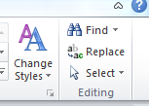
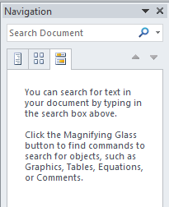

Where the, directory or document/file is not known, then an advanced search will have to be done using specific words or text to guide the process. This style of search enables you to identify the documents or files that contain the key words or phrases without having to open and search all documents or files individually.
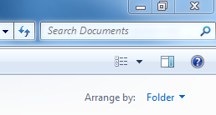
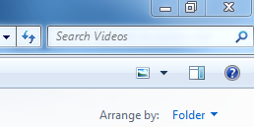

Searches can be made of a particular directory through the directories page or through the Start icon which will search directories and files. You can search all libraries or a specific directory.

Activity 22 – Enter Data
NOTE: It is a requirement of this unit that you attempt this Training Activity.
You are required to enter data onto an automated information system.
The requirements for this activity are met in Activity 20 – Manipulate information.
Complete this activity by entering the required data into Activity 20 and providing the printout to your trainer.

5.2 Save and back-up data

Introduction
Files generated fall under two categories; active or inactive. Active files need to be readily accessible for staff to review or update as needed. Inactive files may still need to be accessed but on a less regular basis, in which case they are removed to a storage location or archive folder. Whatever the reason documents need to be stored it is important they are stored logically for ease of reference and security.

Save, close and backup data
In most cases you will be required to save any work done in a file and then close that file.
Saving and closing must become second nature, as should backing up work that has been done.
This may simply mean copying the work to one of the storage files in the hard drive.
Some workplaces require staff to save and close all documents if they have to leave their workstation.
After creating or amending files, documents and records it is important that you are able to store data appropriately and then exit the application without damage and without loss of data.
The storage of data may include:
Storage in directories and sub-directories – these may be allocated random names or titles but in most large establishments have specified policies and procedures regarding this.

Storing reference information
Although it is still common for travel agents to keep a lot of printed information as reference material, there are a number of reasons for trying to reduce paper files and to store and access information electronically. Paper files take up a lot of space, can be a challenge to file appropriately and also can become outdated quite quickly. It is much more logical to know how to access information from saved computer files, or ideally from reliable online sources, and to print as required:
- Storage on hard drives – this is the most common form of saving and storing data on the computer’s hard drive/c: drive. Most premises do this and many small operations don’t bother backing up this option. If there is a fire or theft, industrial espionage or a simple hard drive crash or corruption – the results can be dramatic
- It is true that no-one can understand how damaging or how shattering a total hard drive loss is unless they have experienced one
- Storage on USB/thumb drives - This method involves saving the files from the hard drive to the USB. In some cases the files are also left on the hard drive and continue to be modified and in other cases once the file has been transferred to the USB the hard drive copy is deleted to free up space
- Storage on networked computers – some properties back-up data other than hard drives within the network. This is common in large organisations

- Appropriate storage or filing of hard copies of computer generated documents – in some cases a hard copy of data may be taken and filed or archived for future use. While hard copies cannot be readily amended unless they are retyped into the computer or scanned in, they at least provide a source document for future reference
- Hard copies may not be very ‘high-tech’ but it is amazing how valuable they become when the hard drive crashes, or there is a power or some other failure and the data from the hard drive is unavailable.

Archiving
Archiving is the practise of removing a file from regular use and storing it in another location. The file is not disposed of simply transferred into a storage location where it may need to be accessed only occasionally as a reference source or historical data or some other reason.
Computer files may be removed from common share drives and stored in a central drive that the business uses as its main storage location. Files are generally stored according to company policy which may include:
- By year
- Department
- Subject
- Numerically
- Alphabetically
- Chronologically
- Geographically.
It is vital this area is managed efficiently to prevent files becoming disorganised.
Files may be moved to archive for the following reasons:
- To make room for other files
- They are not used as often
- Many records are required by law (business, tax)to be kept for a minimum period, often 5-7 years.
A backup is a secondary copy made to protect information against accidental loss or damage; many establishments buck-up their records and files on a daily basis. Doing back-up means you can restore information quickly and with confidence so that you return to the point where you were before the loss occurred.
The loss of information may be caused by human error, sabotage, technical failure theft or even a major incident such as fire or flood.
Back-up copies of all important programs and data should always be maintained; it must become standard operating procedure to back-up files including the hard drive.
The higher the value of the data, the more important it is to the organisation – therefore the more comprehensive the back-up system should be.
The back-up procedure should include daily back-ups with a weekly off site backup copy.

Activity 23 – Save and backup data
NOTE: It is a requirement of this unit that you attempt this Training Activity.
This unit (or course) has required you to create a number of documents.
You are required to take several screen shots of your filing and storage system to demonstrate how you are saving and storing your data:
- Screenshot 1 named file or files
- Screenshot 2 named documents within each of the above files
- Screenshot 3 showing your backup copy on another storage area/drive or removable device.

Work Projects
It is a requirement of this Unit you complete Work Projects as advised by your Trainer. You must submit documentation, suitable evidence or other relevant proof of completion of the project to your Trainer by the agreed date.
5.1 Please complete the following activities relating to this Performance Criteria:
- Activity 21
5.2. Please complete the following activities relating to this Performance Criteria:
- Activity 22

Summary

Up-date and maintain information on an automated information system
Enter data onto automated information system
- Update and maintain information
- Locating data.
Save and back-up data
- Save, close and backup data
- Storing reference information
- Archiving.

Presentation of written work

Introduction
It is important for students to present carefully prepared written work. Written presentation in industry must be professional in appearance and accurate in content. If students develop good writing skills whilst studying, they are able to easily transfer those skills to the workplace.

Style

Students should write in a style that is simple and concise. Short sentences and paragraphs are easier to read and understand. It helps to write a plan and at least one draft of the written work so that the final product will be well organised. The points presented will then follow a logical sequence and be relevant. Students should frequently refer to the question asked, to keep ‘on track’. Teachers recognise and are critical of work that does not answer the question, or is ‘padded’ with irrelevant material. In summary, remember to:
- Plan ahead
- Be clear and concise
- Answer the question
- Proofread the final draft.

Presenting Written Work
Types of written work
Students may be asked to write:
- Short and long reports
- Essays
- Records of interviews
- Questionnaires
- Business letters
- Resumes.
Format
All written work should be presented on A4 paper, single-sided with a left-hand margin. If work is word-processed, one-and-a-half or double spacing should be used. Handwritten work must be legible and should also be well spaced to allow for ease of reading. New paragraphs should not be indented but should be separated by a space. Pages must be numbered. If headings are also to be numbered, students should use a logical and sequential system of numbering.
Cover Sheet
All written work should be submitted with a cover sheet stapled to the front that contains:
- The student’s name and student number
- The name of the class/unit
- The due date of the work
- The title of the work
- The teacher’s name
- A signed declaration that the work does not involve plagiarism.
Keeping a Copy
Students must keep a copy of the written work in case it is lost. This rarely happens but it can be disastrous if a copy has not been kept.
Inclusive language
This means language that includes every section of the population. For instance, if a student were to write ‘A nurse is responsible for the patients in her care at all times’ it would be implying that all nurses are female and would be excluding male nurses.
Examples of appropriate language are shown on the right:
Mankind | Humankind
Barman/maid | Bar attendant
Host/hostess | Host
Waiter/waitress | Waiter or waiting staff

Recommended reading
Evans, Dave; Learning Social Media Marketing: A Video Introduction (DVD); video2brain
Frost, W., 2004; Travel and tour management; Pearson Education Australia, Frenchs Forest, NSW
Kerpen, Dave; 2011 (1st edition); Likeable Social Media: How to Delight Your Customers, Create an Irresistible Brand, and Be Generally Amazing on Facebook (And Other Social Networks); McGraw-Hill
Macarthy, Andrew; 2013 (1st edition); 500 Social Media Marketing Tips: Essential Advice, Hints and Strategy for Business: Facebook, Twitter, Pinterest, Google+, YouTube, Instagram, LinkedIn, and More; CreateSpace Independent Publishing Platform
Van der Wagen, L. & Goonetilleke, A., 2012 (3rd ed’n); Hospitality management: strategy and operations; Pearson Publications, Frenchs Forest, NSW
Wicks, G., 2005 (Revise ed’n); Tour planning and operations for wholesalers and tour operators; Adelaide Institute of TAFE, South Australia
Zimmerman, Jan; 2012 (2nd edition); Social Media Marketing All-in-One For Dummies; For Dummies

Trainee evaluation sheet

Operate an automated information system
The following statements are about the competency you have just completed.
Please tick the appropriate box | Agree | Don’t Know | Do Not Agree | Does Not Apply
There was too much in this competency to cover without rushing.
Most of the competency seemed relevant to me.
The competency was at the right level for me.
I got enough help from my trainer.
The amount of activities was sufficient.
The competency allowed me to use my own initiative.
My training was well-organised.
My trainer had time to answer my questions.
I understood how I was going to be assessed.
I was given enough time to practice.
My trainer feedback was useful.
Enough equipment was available and it worked well.
The activities were too hard for me.

The best things about this unit were:

The worst things about this unit were:

The things you should change in this unit are:

Trainee self-assessment checklist
As an indicator to your Trainer/Assessor of your readiness for assessment in this unit please complete the following and hand to your Trainer/Assessor.

Operate an automated information system
 |  | Yes | No*
Element 1: Identify the context for use of an automated information system
1.1 | Identify a range of information systems and sources in use within the industry
1.2 | Describe policies and procedures for operating an automated information system
1.3 | List information that may be available through an automated information system
1.4 | Identify the functions of an automated information system
Element 2: Access information using an automated information system
2.1 | Identify information requirements
2.2 | Identify and select appropriate sources of information
2.3 | Apply search techniques to locate identified information
2.4 | Interrogate the system to secure full range of information available on the system
2.5 | Verify captured information meets identified need
Element 3: Obtain information using an automated information system
3.1 | Enable access to required system and/or information
3.2 | Select required information
3.3 | Download information
3.4 | Print information
Element 4: Use information from information an automated information system
4.1 | Forward information as required
4.2 | Save identified information
4.3 | Manipulate accessed information
4.4 | Report on findings
Element 5: Up-date and maintain information on an automated information system
5.1 | Enter data onto automated information system
5.2 | Save and back-up data
Statement by Trainee:
I believe I am ready to be assessed on the following as indicated above:
Signed: _____________________________ | Date: ____________

Note:
For all boxes where a No* is ticked, please provide details of the extra steps or work you need to do to become ready for assessment.





